The Théa inteRnational cOntest of clinical cases in PatHologies of the eYE (TROPHY)

NOVEL APPROACHES TO THE DIAGNOSIS AND MANAGEMENT OF THE DRY EYE DISEASE
Acute versus chronic ocular graft vs. host disease : severe immune-mediated dry eye disease

INTRODUCTION
Graft-versus-host disease (GVHD) is a multisystem disorder which is a common complication of hematopoietic stem cell transplantation (HSCT). GVHD occurs when the donor CD4+ and CD8+ T cells identify the recipient’s own histocompatibility antigens as foreign and initiate an immune reaction that causes disease in the transplant recipient [1,2]. According to the National Institutes of Health (NIH), GVHD can be classified into two broad categories according to clinical features rather than the temporal relationship to the time of transplantation:
- Acute GVHD (aGVHD) is a multi-organ inflammatory syndrome primarily affecting the skin, liver and digestive tract. It occurs mostly in the first 100 days after HSCT and is stimulated by damaged recipient tissue and amplified by donor T cells.
- Chronic GVHD (cGVHD) is related with thymic damage and impaired negative selection of autoreactive T cells. It usually occurs 100 or more days after HSCT. It may be a continuation of acute GVHD or can occur insidiously. It also involves multiple systems such as the musculoskeletal and haematological system, as well as various organs including the skin, gut, lungs and eyes [2].

Ocular GVHD
Ocular GVHD (oGVHD) develops in approximately 40-60% of patients following HSCT and in 60 to 90% of patients with systemic GVHD [3,4]. Acute GVHD accounts for only 1% of the oGVHD [5]. The inflammation, caused by the donor T cells, destroys the Meibomian glands located at the eyelid margins, the surface epithelium of the conjunctiva and cornea, the goblet cells and the lacrimal glands. This results in severe ocular surface problems [2]. Manifestations of oGVHD range from mild conjunctivitis to severe cicatricial conjunctivitis and corneal perforation. The most frequent reported symptom of oGVHD is keratoconjunctivitis sicca (KCS), commonly known as dry eye disease. It typically develops 6 to 9 months after HSCT [6,7]. Severe ocular manifestations such as pseudomembranous conjunctivitis, corneal epithelial defects and corneal melting are associated with severe systemic GVHD and a poor survival [1,2]. Ocular symptoms are mostly more severe in cGVHD. Conjunctival involvement in aGVHD is a prognostic factor for a higher mortality rate [8].
The onset of oGVHD after HSCT is variable and is influenced by the donor-recipient matching characteristics. In the majority of patients with GVHD ocular involvement follows the occurrence of systemic manifestations; however, importantly, it can also precede or develop independently of systemic disease in a minority of patients [1,3]. Symptoms of KCS caused by oGVHD can easily be recognized by the haematologist or the general practitioner. Early referral to the ophthalmologist is important [7]. Unfortunately, ocular GVHD is often misdiagnosed [9].

Treatment of oGVHD
Treatment of patients with ocular GVHD is twofold : it includes both the treatment of the systemic and the ocular manifestations of GVHD. The systemic treatment of GVHD consists of corticosteroids, cyclosporin and/or other immunosuppressive medication [2].
The ocular therapy includes preservative free topical lubricants, antibiotics and steroids, eye patching, gas permeable bandage soft contact lenses, rigid scleral lenses, punctal occlusion, topical immunosuppresion (cyclosporine A and tacrolimus), local mucolytic therapy (acetylcysteine), autologous serum drops, conjunctival patch, scleral patch and/or tarsorrhaphy [2,8].

CASE PRESENTATION

Case 1
The first patient is a 62 year old man who underwent HSCT for acute myeloid leukaemia (AML). He developed aGVHD 3 months after the second HSCT, with skin and ocular problems, despite treatment with mycophenolate mofetil and tacrolimus. The skin biopsy was suggestive for GVHD. Systemic immunosuppressive drugs and antibiotics were started (intravenous methylprednison 2 mg/kg and Sulfamethoxazol + trimethoprim) by the haematologist.
At presentation, Snellen visual acuity (VA) was 0.1 at the right eye and 0.4 at the left eye. Slit lamp examination showed a bilateral pseudomembranous conjunctivitis, blepharitis and filamentary keratitis with extensive superficial punctate epithelial defects (Fig 1). The conjunctival pseudomembranes were only noticeable if the eyelids were completely everted.

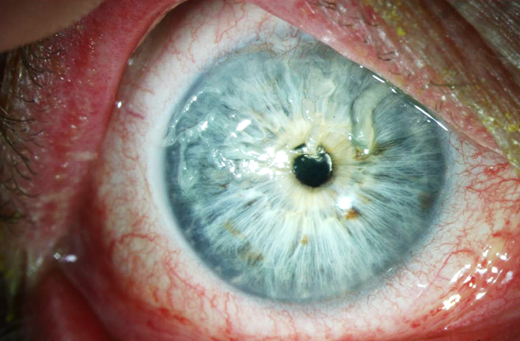
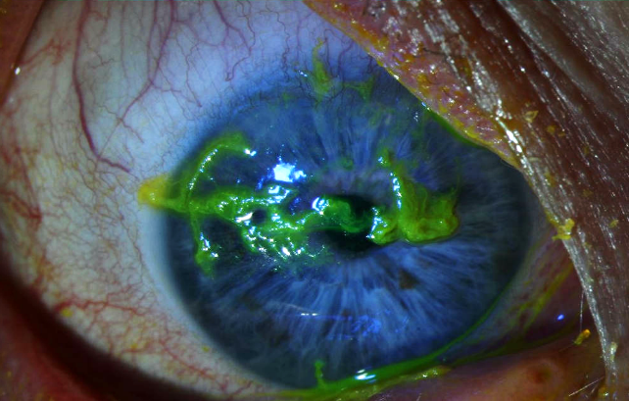
(a) (b)

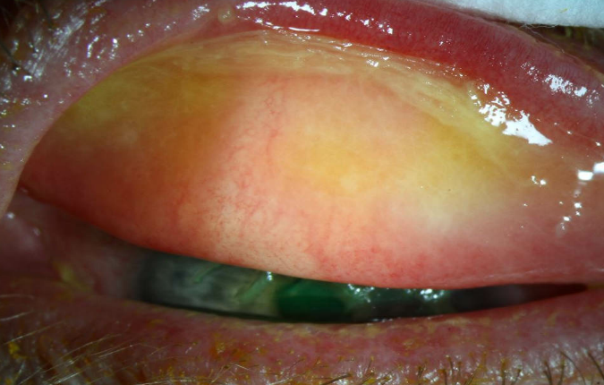
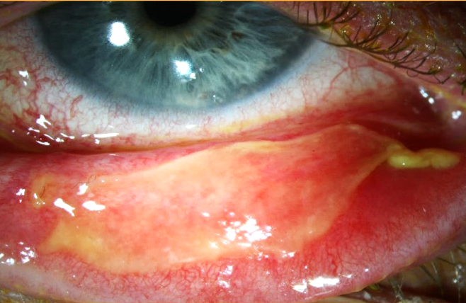
(c) (d)

Fig. 1. Slit lamp examination of the right eye at presentation. Notice the corneal filaments (a-b) and the conjunctival pseudomembranes (c-d).
The treatment included a bilateral corneal scraping and removal of the conjunctival pseudomembranes. After placing a therapeutic soft contact lens, preservative-free ofloxacin, dexamethason and artificial tears were administered. Associated blepharitis was treated with eyelid scrubs and minocycline 100 mg/day. We evaluated our patient every other day. After 10 days VA had increased to 0.8 at the right eye and 0.6 at the left eye. Corneal filaments and pseudomembranes did not recur. Topical ofloxacin and dexamethasone were tapered and the therapeutic contact lens was removed.
One week later, VA increased to 1.0 at the right eye and 0.9 at the left eye. Slit lamp examination showed only mild keratopathy. We continued oral minocycline, topical dexamethason and artificial tears. Follow up was planned after 1 month but due to systemic complications the patient had already passed away before that consultation.

Case 2
Our second patient is a 54 year old woman who developed cGVHD 7 months after HSCT for AML. GVHD was confirmed by skin biopsy, and characterized by liver dysfunction, skin and ocular problems.
The haematologist started her on immunosuppressive medication: high-dose steroids, sirolimus and tacrolimus. At presentation she complained of dry, burning eyes and a decreased vision.
Slit lamp examination revealed a blank conjunctiva, superficial epithelial defects with filaments in both eyes, more pronounced in the left eye. VA was 0.8 and 0.2, respectively at the right and left eye. Topical treatment with preservative-free dexamethason and cyclosporine 0.05% was started combined with intense lubrification day (artificial tears) and night (ointment). The epithelial erosions healed and the VA increased to 1.0 and 0.7. The patient was seen every 1-3 weeks with a stable VA and calm anterior segment.

After 3 months she returned to our clinic with complaints of severe photophobia, ocular pain and bilateral vision loss (counting fingers). Slit lamp examination showed a multifocal white corneal infiltrate with overlying epithelial defect at the right eye and a corneal erosion with corneal thinning at the left eye (Fig 2). Also, anterior chamber inflammation was present (cells 2+).

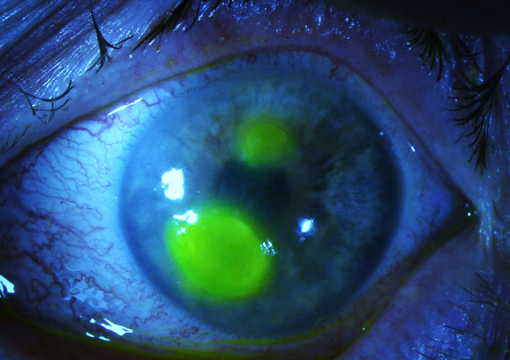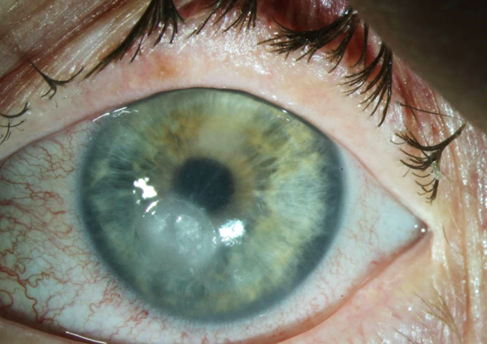

Fig. 2 Slit lamp examination of the right eye, 10 months after presentation. Notice the multifocal corneal infiltrate and multiple epithelial defects.

The patient was hospitalized for 9 days and an empirical treatment with topical voriconazole 1% every hour, moxifloxacin 6x/day and lubrification with preservative-free artificial tears was started. A corneal swab was performed, which showed presence of E. Coli, without fungal infection. The clinical response after therapy was fairly good : the stromal melting stabilized and the infiltrate with overlying epithelial defect diminished. The local therapy was tapered and the antibiotic and antifungal eye drops were stopped. Later on, punctal plugs were placed in both inferior tear duct punctae.
Unfortunately, VA remained low (0.05 and 0.1) because of severe irregular corneal astigmatism (Fig 3 and 4). Scleral contact lenses were prescribed to treat symptoms of dry eye disease and to improve her VA. With these contact lenses VA improved to 0.3 (right eye) and 0.6 (left eye) and a positive effect on dry eye symptoms was noted. Schirmer’s test result was 3mm and 7mm on the right and left eye, respectively.

Fig.3 Slit lamp examination of the right (up) and left eye (down), 2 years after presentation.
Right eye : notice two epithelial defects - Left eye : notice epitheliopathy

Fig. 4 Corneal topography and OCT of the right (up) and left eye (down), 2 years after presentation. Notice the corneal thinning and astigmatism in both eyes.

In order to control ocular inflammation and prevent recurrent corneal melting, our patient was then started on topical hydrocortisone and tacrolimus 0.03% drops combined with hydrocortisone ointment every other night. Intense lubrification with autologous serum 20% eye drops, alternated with preservative-free artificial tears, and VitA-Pos ointment was added. This treatment, combined with the scleral contact lenses, had a positive effect on the ocular surface complaints and VA. Later on, topical tacrolimus 0.03% drops were replaced by topical cyclosporine A 0.05% drops because of recurrent deposits on the scleral contact lens surface caused by tacrolimus eye drops, the latter being diluted in sterile olive oil vehicle.
At the last consultation, our patient had a mild keratopathy with stromal thinning and a stable VA with scleral contact lenses (Fig 5). The VA without scleral contact lenses was counting fingers at 3m and 0.15 on the right and left eye respectively. A Schirmer’s test showed a complete absence of tear production (0mm on both sides).

Fig. 5 Slit lamp examination of the right and left eye, at the last consultation.

DISCUSSION
In this case series we report two cases of severe immune-mediated dry eye disease: one patient with acute ocular GVHD and one patient with chronic ocular GVHD. Both patients underwent HSCT for AML and postoperatively reported serious symptoms of dry eye disease (burning, itching sensation with photophobia) and a decreased vision at presentation, combined with systemic manifestations of GVHD (skin and gastrointestinal problems). In both cases the GVHD was biopsy-proven. In both patients corneal involvement was noticed, varying from keratopathy to filamentary keratitis and corneal ulceration.

In our first patient with acute ocular GVHD we noticed an acute start of complaints with a fast recovery after removal of the conjunctival pseudomembranes and corneal scraping, combined with bandage soft contact lens (BSCL) and treatment with topical steroids and lubrification. The patient also received high dose systemic corticosteroids (180 mg methylprednison/day).
In aGVHD ocular manifestations are rather rare (7.2%) and conjunctival involvement with pseudomembrane formation is a negative marker for systemic involvement [8].
In our patient, the early recognition and aggressive treatment of the oGVHD resulted in a complete recovery of vision and minimal dry eye symptoms.
Combining bandage soft contact lenses (BSCL) with intense lubrification and local and systemic corticosteroids was an efficient treatment modality for acute oGVHD.

*Intense lubrification (artificial tears)
For lubrication, the patient can use preservative-free artificial tears to coat the ocular surface, thereby minimizing superficial punctate keratopathy, decreasing ocular symptoms, and improving quality of vision. Because patients may tolerate certain formulations better than others, they should be encouraged to test different brands to identify one that provides the most benefit [10].
*Bandage soft contact lens
A study from 2015 concluded that BSCL are a safe, tolerable and effective treatment option for patients with moderate to severe oGVHD. Approximately 50% of patients who are symptomatic despite conventional treatments had a relief of symptoms with BSCL. Since BSCL are widely available and do not require a high initial expense or time commitment, they could be used as the initial protective lenses for patients with oGVHD [11]. A study with 20 oGVHD patients showed that 55% (11 patients) had a positive clinical effect with BSCL and intense lubrification [6].
*Topical corticosteroids
Owing to the critical role of inflammation in ocular GVHD, topical steroids have been a key treatment for ocular surface disease in acute and chronic ocular GVHD. In one report with 10-year follow-up, topical steroids were used in more than one third of ocular GVHD dry eye patients [12]. Clinical evidence of their efficacy, however, is lacking.
Older studies reported that topical steroids did not influence either the clinical aspects or the histologic course of pseudomembranous conjunctivitis in acute GVHD [10]. A 2006 study by Kim et al, however, demonstrated that early and aggressive topical steroid therapy led to improved healing and decreased corneal scarring in stage IV ocular GVHD (pseudomembranous conjunctivitis with corneal epithelial sloughing) [13]. Robinson et al reported the resolution of conjunctival hyperemia and improvement in conjunctival cicatricial changes with topical prednisolone acetate 1% in GVHD patients [14]. A study comparing the effect of topical steroids in dry eye disease between patients with and without oGVHD showed a less favorable response to a low-dose topical steroid regimen of oGVHD patients compared with those without oGVHD even with similar baseline disease severity [12].
Our second patient with chronic ocular GVHD had a more fluctuating clinical course. She presented with complaints of dry eyes. She was treated with systemic and local corticosteroids and immunosuppressants (tacrolimus and cyclosporine A), intense lubrification (preservative-free artificial tears, autologous serum eye drops) and scleral contact lenses. She developed bilateral corneal erosions with stromal thinning.
Corneal involvement is a frequent complication in oGVHD patients. In a retrospective observational study 4 of 243 oGVHD patients developed corneal ulcerations attributable to oGVHD, requiring penetrating keratoplasty. Frequent follow-up and bilateral monitoring are highly recommended in cases of oGVHD-associated stromal thinning, as bilateral involvement or rapid progression to corneal perforation can occur [15].
In our patient, ocular surface inflammation could only be controlled combining aggressive topical and systemic treatment modalities including of topical hydrocortisone, tacrolimus, autologous serum eye drops, preservative-free artificial tears, scleral contact lenses, systemic steroids and sirolimus.

*Intense lubrification (autologous serum)
Intense lubrification with (preservative-free) artificial tears is the first-line treatment in any patient with symptoms of dry eyes. If there is not enough improvement with that therapy, one can use autologous serum (AS) drops. Although the mechanisms through which autologous serum eye drops improve dry eye after allogeneic SCT remain to be elucidated, there are a couple of plausible explanations.
Tear components, such as epidermal growth factor (EGF) and vitamin A, are important for the proliferation, differentiation and maturation of ocular surface epithelium. Cultures of human corneal stromal fibroblasts and endothelial cells were reported to express EGF receptors and to increase their DNA synthesis in the presence of EGF. Artificial tears made from autologous serum could supply these factors and improve the condition of the ocular surface. Corneal sensitivity tends to recover after treatment with the autologous serum eye drops. The presence of nerve growth factors in serum may explain this tendency [16]. A study in 2017 showed no side effects with 100% autologous serum eye drops in patients with oGVHD. It seems to be a safe alternative despite earlier suspicions regarding immune complex accumulations and exacerbation of ocular surface inflammation [17]. Another case report evaluating 2 oGVHD patients treated with AS drops for 10 months also confirmed the safety of AS in this specific population [18]. While AS drops may provide an alternative treatment in moderate and severe cases of dry eye which have not responded to conventional tear replacement therapy, a randomized, double-blinded, clinical study would be useful to determine whether the benefits and safety of AS drops are generally applicable to GVHD-related dry eye disease [18].
*Local immunosuppression
Several clinical trials have shown topical cyclosporine A (CsA) 0.05% to be safe and effective in the treatment of moderate to severe dry eye disease. It is suggested that topical CsA may also be beneficial in dryness caused by oGVHD. Studies showed a significant improvement of clinical signs (Schirmer, break-up time, fluorescein staining) and symptoms [19]. CsA functions by inhibiting T-cell proliferation, downregulating inflammatory cytokines, and increasing goblet cell density in the conjunctiva [11,20,21]. It is suggested that it is also effective in patients unresponsive to other, more traditional treatments for dry eye, as artificial tears. There were no serious adverse events reported. [20,21]. CsA in a olive oil vehicle was well tolerated [22].
One study, including 20 patients showed that topical CsA as a prophylactic measure for oGVHD, administered over a period of 1 year after grafting may decrease the incidence of ophthalmic manifestations of GVHD. These findings must be confirmed in a randomized trial [23]. Some patients present local or systemic intolerance to cyclosporine and cannot be treated with this drug. For that, topical tacrolimus is an alternative. It impairs T-cell activity via inhibition of the calcineurin enzyme and is reported to be more potent than CsA [11]. This finding is suggested in an open-label, single-center prospective study which shows that 0.03% tacrolimus eyedrops improve symptoms and signs of dry eye associated with GVHD in cyclosporine-intolerant patients. This study also shows that 0.03% tacrolimus is as safe and effective as 0.05% cyclosporine eyedrops; making 0.03% tacrolimus eyedrops a new therapeutic alternative for dry eye in GVHD patients. These findings should be confirmed with a randomized, double-masked, multicenter, placebo-controlled trial [21]. A phase I/II randomized, double-masked clinical trial comparing topical tacrolimus 0.05% and topical methylprednisolone 0.5% in patients with ocular GVHD found that topical tacrolimus was safe and well tolerated. It was effective in reducing Corneal fluorescein staining (CFS) and Ocular Surface Disease Index (OSDI) scores and in decreasing the expression of ICAM-1 and HLA-DR without the hypertensive effects of topical corticosteroids [11]. Tacrolimus has been used at different concentrations, from 0.005% to 0.1%, and compounded with different vehicles, such as olive oil and balanced salt solution, and rendered mixed results in the treatment of ocular surface diseases. To date, there is no consensus regarding the optimal concentration or vehicle to formulate topical tacrolimus [24]. In a 2015 study with 26 oGVHD patients, more than 90% of the patients required one or more therapies in addition to artificial tears. When topical anti-inflammatory therapy was added, 54.3% had improvement of symptoms. Of the remaining, when non-diluted autologous serum tears were added, 80% had improvement and required no other treatments [25].
*Bandage soft contact lenses (BSCL) and scleral contact lenses (SCL)
Multiple studies showed an increase in VA and quality of life when using scleral contact lenses in oGVHD patients. In a series of 33 patients, Jacobs et Rosenthal reported a decrease in pain and photophobia in 52 and 63% of the patients respectively [26]. A retrospective study with 16 cGVHD patients, showed an improvement of the ocular surface based on the OSDI score after starting with scleral contact lenses. Scleral contact lenses maintain a constant liquid reservoir over the cornea, so the evaporation of tears is diminished with a protective effect on the ocular surface [27, 28]. In a study with 9 patients, all patients with scleral contact lenses for severe cGHVD-related KCS reported a significant reduction in topical lubricant use [23]. In a study with 20 oGVHD patients who were started on BSCL, 9 of them did not have a enough clinical reponse and needed a SCL. The total prevalence of infectious adverse effects leading to discontinuation of BSCL or SCL lens wear was 14% (n = 3/21): herpetic keratitis (n = 2, 1 BSCL and 1 SCL) and pseudomonas keratitis (1 BSCL). Furthermore, two patients presented with a subconjunctival haemorrhage (1 BSCL and 1 SCL). No other adverse events, such as abrasions, neovascularization and papillary conjunctivitis, were observed during contact lens wear [6]. These studies conclude that SCL are a therapeutic modality that could be considered in the management of severe dryness‐related epitheliopathy associated with ocular GvHD.
CONCLUSIONS

Although rare, ocular symptoms can occur in aGVHD with conjunctival pseudomembranes and filamentary keratitis. It is important to recognize and treat acute oGVHD in an early stage to prevent further conjunctival and corneal damage due to the immune-mediated cytokine upregulation. Treatment options include removal of pseudomembranes and corneal filaments, intense lubrification (using preservative-free artificial tears or autologous serum drops), systemic and local corticosteroids and bandage soft contact lenses. Aggressive treatment of acute oGVHD can result in rapid resolution of ocular signs and symtoms.
Ocular symptoms in cGVHD can be more difficult to manage. Intense lubrification with autologous serum drops, topical corticosteroids and a bandage soft contact lens might not be sufficient. Often, aggressive treatment combining local and systemic immunosuppression and/or scleral contact lens wear is necessary to control ocular inflammation and prevent complications.

Given the potentially devastating nature of both acute and chronic oGVHD, treatment should be coordinated by a multidisciplinary team addressing both ocular and systemic manifestations.

REFERENCES
- Ryan Blackburn, Brett H. Mueller II, DO, PhD, and Aparna Ramasubramanian, MD
Edited by Sharon Fekrat, MD, and Ingrid U. Scott, MD. A Stepwise Approach to the Ocular Manifestations of Graft-vs.-Host Disease. EyeNet Magazine / May 2017
- Claes K, Kesteleyn P. Ocular Manifestations of Graft versus Host Disease following Bone Marrow Transplantation. Bull. Soc. Belge Ophtalmol. 277, 21-26. 2000
- Hasanain Shikari, Francisco Amparo, Ujwala Saboo, Reza Dana. Onset of Ocular Graft-versus-Host Disease Symptoms after Allogeneic Hematopoietic Stem Cell Transplantation. Cornea. 2015 Mar; 34(3): 243–247.
- Ferrara JL, Levine JE, Reddy P, Holler E (2009) Graft-versus-hostdisease. Lancet 373:1550–1561
- Qiu Y, Hong J, Peng R. Manifestation of clinical categories of ocular graft-versus-host disease. J Ophthalmol. 2018 Aug 8;2018:6430953
- Stoyanova EI, Otten HM, Wisse R, Rothova A, Riemens A. Bandage and scleral contact lenses for ocular graft-versus-host disease after allogeneic haematopoietic stem cell transplantation. Acta Ophthalmol. 2015 Nov;93(7):e604. doi: 10.1111/aos.12711. Epub 2015 Apr 28.
- Stevenson W, Shikari H, Saboo US, Amparo F, Dana R. Bilateral corneal ulceration in ocular graft-versus-host disease. Clin Ophtalmol. 2013;7:2153-8.
- Espana EM, Shah S, Santhiago MR, Singh AD. Graft versus host disease: clinical evaluation, diagnosis and management. Graefes Arch Clin Exp Ophthalmol. 2013 May;251(5):1257-66.
- Peggy Denny. Ocular Graft-vs.-Host Disease: The Downside of Success. EyeNet Magazine / December 2013.
- Couriel D. et al. Ancillary therapy and supportive care of chronic graft-versus host disease: national institutes of health consensus development project on criteria for clinical trials in chronic graft-versus host disease: V. Ancillary Therapy and Supportive Care Working Group Project. Biology of Blood and Marrow Transplantation. 2006; 12(4):375–396.
- Yoshihiro Inamoto, Yi-Chen Sun, Mary E. D. Flowers, Paul A. Carpenter, Paul J. Martin, Peng Li, Ruikang Wang, Xiaoyu Chai, Barry E. Storer, Tueng T. Shen, and Stephanie J. Lee. Bandage soft contact lenses for ocular graft-versus-host disease. Biol Blood Marrow Transplant. 2015 Nov; 21(11): 2002–2007.
- Yin J, Kheirkhah A, Dohlman T, Saboo U, Dana R. Reduced Efficacy of Low-dose Topical Steroids in Dry Eye Disease Associated With Graft-versus-Host Disease. Am J Ophthalmol. 2018 Jun;190:17-23. doi: 10.1016/j.ajo.2018.03.024.
- S.K. Kim, D. Couriel, S. Ghosh, R. Champlin. Ocular graft vs. host disease experience from MD Anderson Cancer Center: newly described clinical spectrum and new approach to the management of stage III and IV ocular GVHD. Biol Blood Marrow Transplant, 12 (2) (2006), pp. 49-50.
- M.R. Robinson, S.S. Lee, B.I. Rubin, et al. Topical corticosteroid therapy for cicatricial conjunctivitis associated with chronic graft-versus-host disease. Bone Marrow Transplant, 33 (10) (2004), pp. 1031-1035
- Stevenson W, Shikari H, Saboo US, Amparo F, Dana R. Bilateral corneal ulceration in ocular graft-versus-host disease. Clin Ophtalmol. 2013;7:2153-8.
- Ogawa Y, Okamoto S, Mori T, Yamada M, Mashima Y, Watanabe R, Kuwana M, Tsubota K, Ikeda Y, Oguchi Y. Autologous serum eye drops for the treatment of severe dry eye in patients with chronic graft-versus-host disease. Bone Marrow Transplant. 2003 Apr;31(7):579-83.
- Tahmaz V, Gehlsen U, Sauerbier L, Holtick U, Engel L, Radojska S, Petrescu-Jipa VM, Scheid C, Hallek M, Gathof B, Cursiefen C, Steven P. Treatment of severe chronic ocular graft-versus-host disease using 100% autologous serum eye drops from a sealed manufacturing system: a retrospective cohort study. Br J Ophthalmol. 2017 Mar;101(3):322-326.
- EM Rocha, FSA Pelegrino, CS de Paiva, AC Vigorito & CA de Souza. GVHD dry eyes treated with autologous serum tears. Bone Marrow Transplantationvolume 25, pages1101–1103 (2000).
- Levy O, Labbé A, Borderie V, Laroche L, Bouheraoua N. Topical cyclosporine in ophthalmology: Pharmacology and clinical indications. J Fr Ophtalmol. 2016 Mar;39(3):292-307.
- Wang Y., Ogawa Y., Dogru M., Kawai M., Tatematsu Y., Uchino M., et al. Ocular surface and tear functions after topical cyclosporine treatment in dry eye patients with chronic graft-versus-host disease Bone Marrow Transplant 2008 ; 41 : 293-302
- Sanz-Marco E, Udaondo P, García-Delpech S, Vazquez A, Diaz-Llopis M. Treatment of refractory dry eye associated with graft versus host disease with 0.03% tacrolimus eyedrops. J Ocul Pharmacol Ther. 2013 Oct;29(8):776-83.
- Stevenson D, Tauber J, Reis BL. Efficacy and safety of cyclosporin A ophthalmic emulsion in the treatment of moderate-to-severe dry eye disease: a dose-ranging, randomized trial. The Cyclosporin A Phase 2 Study Group. Ophthalmology. 2000 May;107(5):967-74.
- Cantú-Rodríguez OG, Vázquez-Mellado A, González-Treviño JL, Martínez-Garza DM, Gómez-De León A, Hawing-Zarate JA, Jaime-Pérez JC, Gutierrez-Aguirre CH, Garza-Acosta AC, Mancías-Guerra C, González-Llano O, González-Cantú GA, Herrera-Rojas MA, Sada-Ovalle I, Gómez-Almaguer D. Cyclosporine A for the Prevention of Ocular Graft versus Host Disease in Allogeneic Hematopoietic Stem Cell Transplant Recipients Is Safe and Feasible. Acta Haematol. 2019 Sep 10:1-7.
- Tulio B Abud, Francisco Amparo, Ujwala S Saboo, Antonio Di Zazzo, Thomas H Dohlman, Joseph B Ciolino, Pedram Hamrah, and Reza Dana. A Clinical Trial Comparing the Safety and Efficacy of Topical Tacrolimus versus Methylprednisolone in Ocular Graft-Versus-Host Disease. Ophthalmology. 2016 Jul; 123(7): 1449–1457.
- Xihiu Lin and Harrison Dwight Cavanagh. Ocular manifestations of graft-versus-host disease: 10 years’ experience. Clin Ophtalmol. 2015; 9: 1209-1213.
- Jacobs D.S., Rosenthal P. Boston scleral lens prosthetic device for treatment of severe dry eye in chronic graft-versus-host disease Cornea 2007 ; 26 : 1195-1199
- Rossi P, Delcampe A, Gueudry J, Duncombe A, Gabison E, Doan S, Muraine M. Gas-permeable scleral lens for management of severe keratoconjunctivitis sicca secondary to chronic graft-versus-host disease. J Fr Ophtalmol. 2015 Nov;38(9):793-9.
- Schornack MM, Baratz KH, Patel SV, Maguire LJ. Jupiter scleral lenses in the management of chronic graft versus host disease. Eye Contact Lens. 2008;34:302–305.

