Subconjunctival platelet-rich plasma injection as a therapeutic resource in severe dry eye disease

Introduction

Dry eye disease is a chronic and frequent condition that affects an average of 35% of population (1). According to the TFOS DEWS II Definition and Classification Subcommittee, the most recent definition of this disorder is established as a multifactorial disease of the ocular surface characterized by a loss of homeostasis of the tear film, and accompanied by ocular symptoms, in which tear film instability and hyperosmolarity, ocular surface inflammation and damage, and neurosensory abnormalities play etiological roles (1,2).

There are two main mechanisms that have been recognized in the ocular surface involvement: tear-deficient and evaporative categories. The first one, also known as hyposecretory dry eye, has traditionally been classified as due to Sjögren syndrome and non-Sjögren syndrome, depending on the presence of an autoimmune exocrinopathy background that includes significant lacrimal gland affection. The second one, also called evaporative dry eye, is usually related to meibomian gland dysfunction and tear film instability, being the most frequent form of clinical presentation. (3,4).

The traditional therapeutic approach includes, from its early stages, patient education, environmental modifications and the use of lubricant eye drops with different lubricating and bioadhesive properties to remain longer on the ocular surface, depending on the polymers that constitute them. That improves the symptoms temporarily, with the important limitation of not supplying the biological natural tear functions and the original mechanism of continuous production, resulting in poor and insufficient effectiveness in those cases of moderate and severe disease (3,4).

Considering that the main objective for the integral treatment of dry eye disease should be aimed at the restoration of tear film homeostasis and the well being of the ocular surface, the use of blood derivates has been popularized due to its recognized epithelial trophic capacity, initially with the development and topical application of autologous serum tears (5), and more recently with the use of platelet-rich plasma, which offers as representative advantages: higher concentration of growth factors, vitamins and anti-inflammatory cytokines that results in a structural and functional profile similar to natural human tears (that enhances tissue regenerative phenomena by stimulating important processes of cell proliferation, migration and differentiation), absence of preservatives in their pharmacological presentation and minimum manufacturing requirements (6–8).

There is strong and growing scientific evidence in the literature related to the use of platelet-rich plasma as a promising therapeutic strategy for those cases of moderate to severe dry eye disease. In the experimental study conducted by Avila and collaborators, the use of platelet-rich plasma injection into the lacrimal gland was evaluated as an alternative treatment for patients with severe dry eye, by showing significant improvement in the subjective results and objective clinical criteria related to the analysis of tear film quality (9).

We present the following fully documented case where we evaluated the use of subconjunctival platelet-rich plasma injection in a patient with rheumatoid arthritis, sjögren syndrome, history of refractive surgery and documentation of severe dry eye disease refractory to treatment, in whom there were applied the different and available related options in the extensive pharmacological and interventional therapeutic arsenal without prior significant clinical improvement.

Case description

The patient is a woman in her mid-forties with a history of rheumatoid arthritis treated with methotrexate and refractive surgery in both eyes more than 15 years ago. The patient consulted with our department complaining about xerophthalmia, ocular pain, red eyes, foreign body sensation, xerostomia, and general dryness sensation.

She was being followed by the service of ophthalmology and rheumatology since the beginning of the symptoms. When she first attended the clinic she had thorough lab tests which evidenced positive antinuclear antibodies, positive anti-Ro antibodies, positive extractable nuclear antibodies, positive anti-La antibodies, and negative anti-Sm, normal renal, hepatic and thyroid tests. She also had a salivary gland gammagraphy with evidence of functional compromise state IV/IV, which provided a diagnosis of Sjögren síndrome with a severe dry eye disease (DED). The patient was initially treated with pulses of topical low potency steroids and permanent hyaluronic acid eye drops; subsequently, carbomer gel and cyclosporine were added after about a year of suboptimal control of symptoms. Though the patient was very complied with the treatment, most of the symptoms, like pain, photophobia, mucous secretion in the mornings, red eyes, foreign body sensation, and blurred visión persisted.

Oculoplastics then decides to occlude the lacrimal orifices, and the usual treatment was continued without any change. In the subsequent visits the symptoms subsided slightly, visual acuity with optic correction was 20/20 in her right eye and 20/60- in her left eye, fluoresceine stain showed punctate and blob staining mostly at the inferior and interpalpebral área of the cornea in the right eye (Fig. 1), the left eye showed a similar pattern of staining, but with a more conglomerated blob in the inferior portion of the cornea (Fig. 2). The lissamine green stain evidenced significant staining in the inferior third, nasal and temporal periphery, likewise, the conjunctiva stained thoroughly in a punctate pattern. According to the Oxford classification, both eyes were scored with III (Fig. 3 and 4). The tear breakup time (TBUT) was 3 seconds for both eyes and the Schirmer test was 0 mm.

Given the suboptimal control of symptoms, we decide to use platelet-rich plasma (PRP) using an innovative application technique. We first explained thoroughly the technique and the potential risks to the patient, who gave us written consent before we began the treatment. Two tubes of blood were extracted and labeled in tubes with EDTA, then those were agitated six times and centrifugated at 3500 rpm’s for ten minutes, the procedure was done the same day. The supernatant was taken and injected with sterile insulin needles under the conjunctiva, we used 500 microliters in the inferior fornix and 100 microliters in each quadrant of the perilimbal area, the procedure was done identically in both eyes using each tube for each of them. The patient was checked one week and one month after the treatment. During all the visits we evaluated the symptoms using the Ocular Surface Disease Index (OSDI) and objective tests including fluorescein and lissamine stains, TBUT and Schirmer test.

A significant improvement was evidenced after the treatment, the OSDI score previous to the application of PRP was 63,63% (moderate to severe grading) and 34,09% (mild to moderate grading) after the injections with PRP. Her visual acuity didn’t change significantly (OD 20/20; OS 20/60). The fluorescein staining was markedly lower after one week (Fig. 5 and 6), the same was evidenced with the lissamine green staining (Fig. 7 and 8) with an Oxford score of I for the right eye and II for the left one. The TBUT was 8 and 7 seconds for the right and left eye respectively, and the Schirmer test was 5 mm for both eyes.

After one month of the application of subconjunctival PRP, the changes seen after one week were stable both in the fluorescein staining (Fig. 9 and 10) and lissamine green staining (Fig. 11 and 12). The TBUT remained in 8 seconds in both eyes and the Schirmer test was 6 and 7 mm for the right and left eyes respectively. There were no reported adverse effects or complications with the subconjunctival PRP administration technique.

Figure 1. Fluorescein staining with cobalt blue filter. Right eye, previous to the PRP administration.

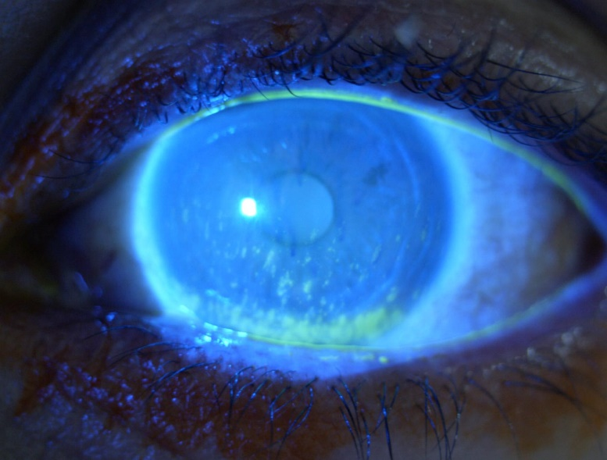

Figure 2. Fluorescein staining with cobalt blue filter. Left eye, previous to the PRP administration.

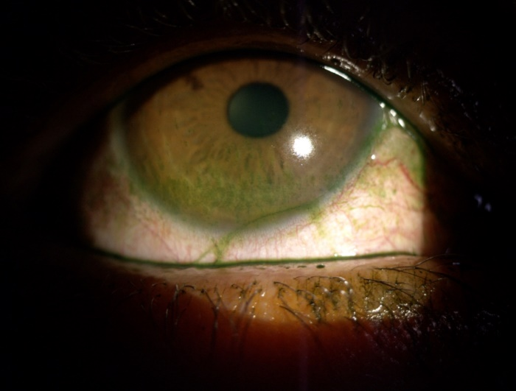
Figure 3. Lissamine green staining. Right eye, previous to the PRP administration.

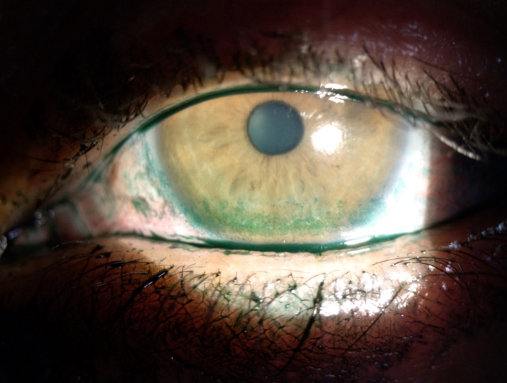

Figure 4. Lissamine green staining. Left eye, previous to the PRP administration.

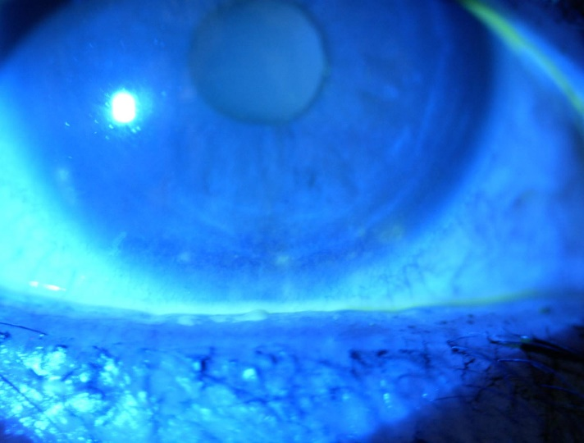

Figure 5. Fluorescein staining with cobalt blue filter. Right eye, one week after the PRP administration.

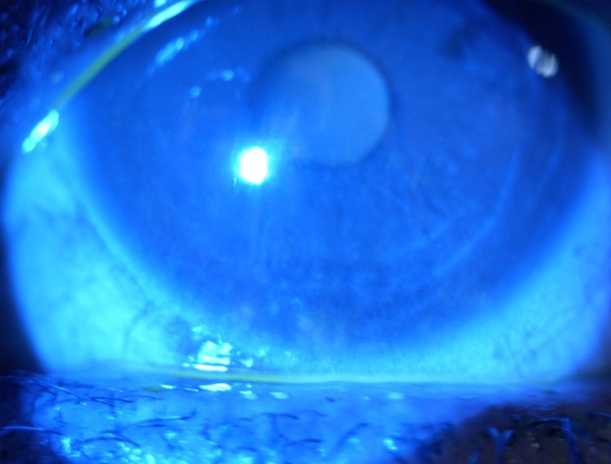

Figure 6. Fluorescein staining with cobalt blue filter. Left eye, one week after the PRP administration.
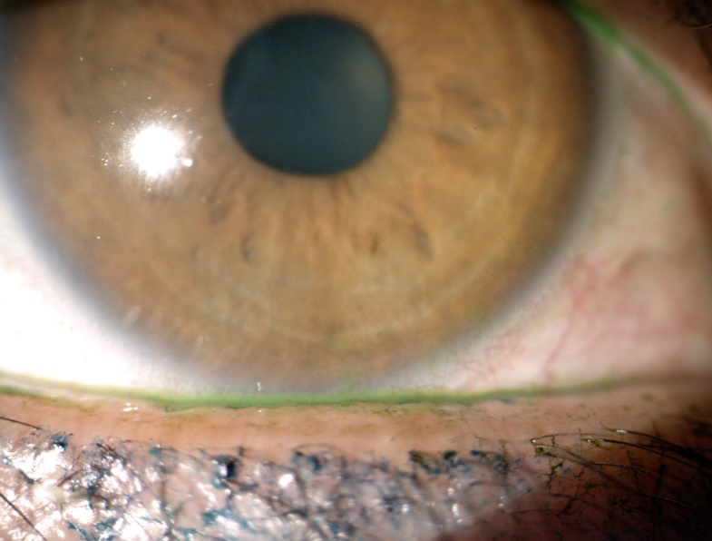

Figure 7. Lissamine green staining. Right eye, one week after the PRP administration.

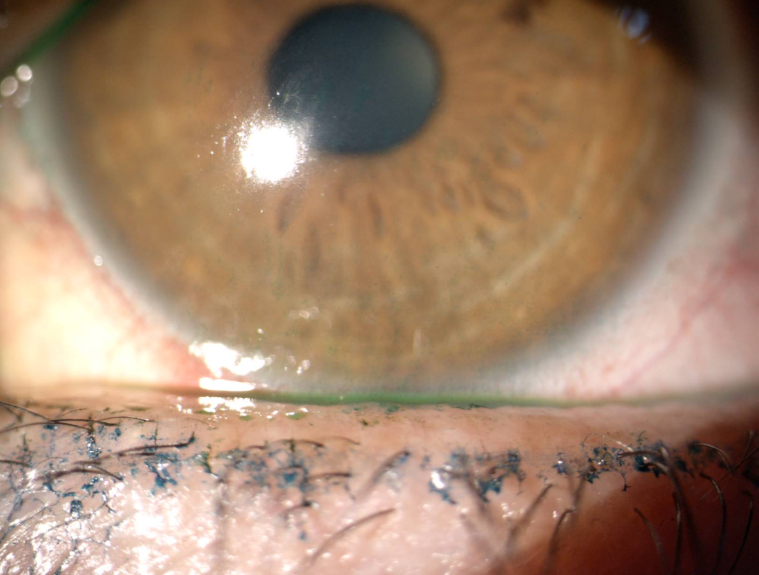

Figure 8. Lissamine green staining. Left eye, one week after the PRP administration.

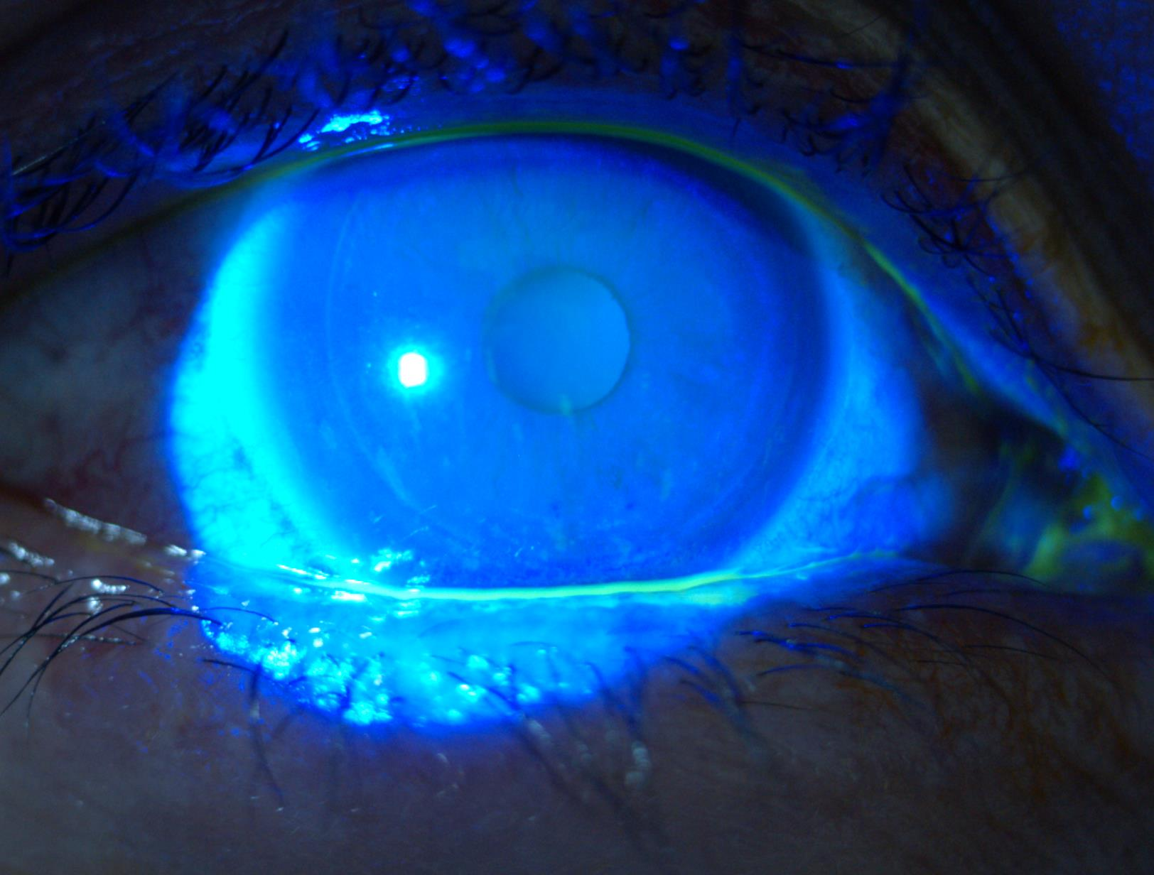

Figure 9. Fluorescein staining with cobalt blue filter. Right eye, one month after the PRP administration.

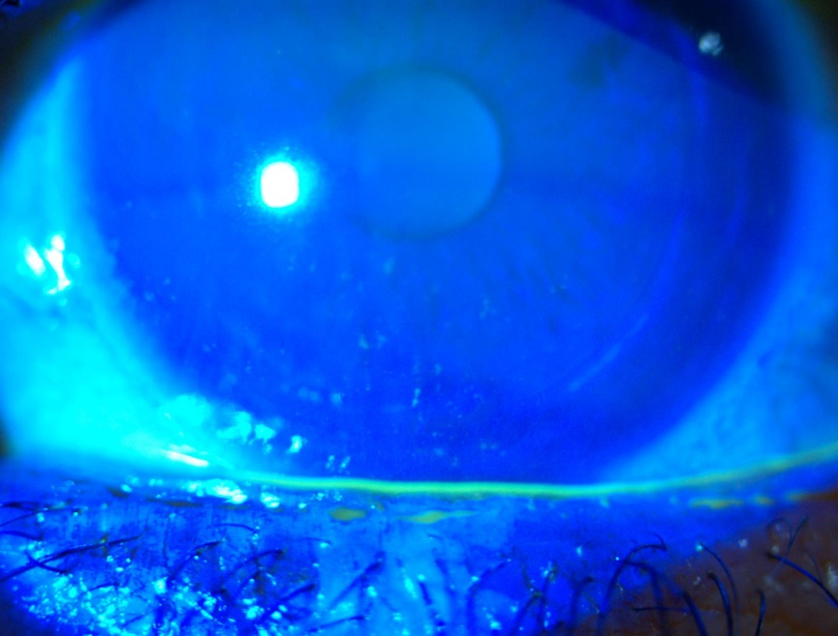

Figure 10. Fluorescein staining with cobalt blue filter. Left eye, one month after the PRP administration.

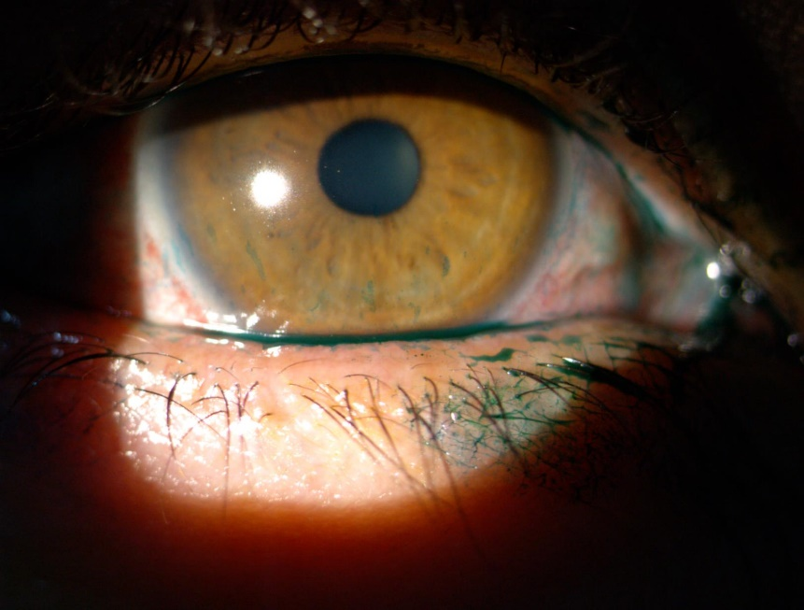

Figure 11. Lissamine green staining. Right eye, one month after the PRP administration.

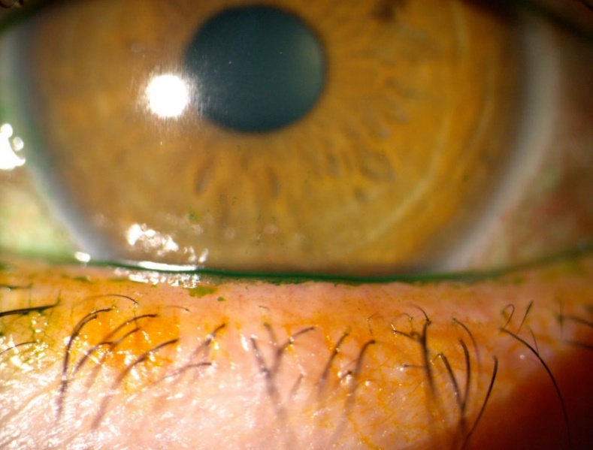

Figure 12. Lissamine green staining. Left eye, one month after the PRP administration.

Discussion

Sjögren syndrome (SS) is the main cause of dry eye due to tear-deficient production. Its annual incidence is 6.92 (95% CI: 4.98–8.86) per 100,000 people and a general prevalence of 60.82 (95%). It is approximately 10 times more frequent in women than in men, and characterized by symptoms of dry mouth and dry eye, ocular surface staining, autoantibodies production and focal lymphocyte infiltrate that affects the salivary glands. Distinctive signs of dry eye in sjögren syndrome include increased corneal staining, goblet cells loss, low tears volume and severe inflammation of the ocular surface (2).

There have been proposed many criteria for SS diagnosis. One of the most commonly used classification criteria is the proposed one by the American-European Consensus Group (AECG), which includes symptoms and signs such as: Schirmer without anesthesia of <= 5 mm / 5 min or ocular surface staining> = 4 according to the van Bijsterveld system. Early diagnosis and management are essential for the optimal management of SS to improve the quality of life and follow patients for verifying the development of systemic complications such as lymphoma. The diagnosis of SS is limited by the sensitivity and specificity of traditional autoantibodies. Antibodies against Sjogren A Syndrome (SSA / Ro) and Sjogren B Syndrome (SSB / La) are only found in 60% to 70 % of patients with SS (2).

Patients with mild symptoms are usually treated with topical lubricants, in order to increase the tear meniscus volume and protect the ocular surface by reducing blink friction and modifying the osmolarity, that has been shown to be proinflammatory. Anti-inflammatory therapy is useful in patients with SS and moderate to severe dry eye disease, since these patients show a marked inflammatory reaction on the ocular surface. Corticosteroids have shown improvement in ocular surface symptoms, as well as reduction on fluorescein staining, filamentous keratitis resolution and notable increase in Schirmer test scores (by more than 2 mm, P <0.05) and goblet cells density. However, the possible complications associated with its long-term use must always be taken into account. Topical cyclosporine has several mechanisms of action that result useful in the dry eye disease management, including the ability to inhibit T lymphocyte activation, apoptosis and calcineurin. It has shown a remarkable decrease in the expression of proinflammatory cytokines and improvement of symptoms, decrease in corneal stippling and increase in the Schirmer test score. Patients may experience pain and discomfort with its application. Secretagogues, such as oral pilocarpine and cevimeline, act on M3 muscarinic receptors of lacrimal and salivary glands. These medications have not been approved for the treatment of dry eye disease, but several studies exhibit some effectiveness in the treatment of dry eye disease in patients with Sjögren syndrome. Goblet cells also contain muscarinic receptors and oral pilocarpine has been shown to increase the goblet cell density. Finally, there can be used invasive resources such as punctal occlusion (4).

Blood derivates have been shown to exhibit healing and regenerative cell capacity attributed to the action of growth factors and bioactive proteins that are synthesized and present in the blood. Growth factors and cell adhesion molecules play an important role in wound healing and improve the physiological related process at injury site. Platelet rich plasma provides a higher concentration of essential growth factors and cell adhesion molecules by concentrating platelets in a small plasma volume, compared to autologous serum (8).

There are few studies that report the use of PRP as an alternative treatment resource for the treatment of dry eye disease. In 2007 Alio et al evaluated 18 symptomatic patients who used this treatment for one month and realized that dry eye symptoms improved in 89% of patients. In 2017 the same author reported a prospective, non-randomized interventional study of 368 patients, where patients with moderate to severe dry eye disease were included. The results showed significant improvement of the Schirmer test and subjective symptoms in 87.5% of the cases. The OSDI scores were statistically significant, 28.8% experienced an increase of one or more lines of vision, the decrease in the corneal staining was observed in 76.1% of patients, and only one patient reported intolerance to the use of PRP due to discomfort at the time of instillation (5).

The autologous PRP is a biological product without preservatives, obtained from the patient's own blood and, due to the presence of platelets and many active biological agents, it is an ideal resource to take into account in the integral management of dry eye disease. PRP plasma preparation can be presented in the two available formulations, topical ophthalmic solution and in clot (10), it is economical in certain countries with easy access, requires strict sterility conditions and is carried out within a laminar flow hood. No serious adverse effects have been described. Considering that the form of eye drops needs a frequent application and shows lower efficacy after prolonged treatment with poor adherence, as well as difficult access to preparation in our country, we propose subconjunctival PRP injection in order to overcome these significant obstacles and stimulate the well-being of the ocular surface.

To date, the only alternative administration method for the investigated PRP had been the direct injection in the lacrimal glands, achieving excellent results in the study conducted by Ávila, et al (9). The subconjunctival injection used in the present exposed clinical case is a novel therapeutic alternative which has never been tried before and has as advantages a simpler administration method for the PRP in monotherapy, and as evidenced previously, the achievement of very good results in a patient with severe dry eye disease with poor response to conventional treatment and who had many important risk factors that worsened her condition, including the history of refractive surgery, and the presentation of sjögren syndrome and rheumatoid arthritis as the main comorbidities.

Conclusions

Subconjunctival platelet-rich plasma injection represents a safe and effective alternative therapy for the comprehensive management of severe dry eye disease with prior poor response to conventional treatment, showing remarkable improvement in objective clinical parameters and evaluators of ocular surface inflammation and tear film quality and stability, as well as in the subjective criteria assessed by the OSDI test, with a final satisfactory result of the patient's perception of improvement in her global condition and subsequent behavior for daily activities, with favorable impact on the quality of life. We consider taking this technique into account as a valid, safe and effective therapeutic resource, especially useful in patients with severe disease and no improvement with the usual treatment, as well as in those who present poor adherence to topical instillation of eye drops, including blood derivates, in which case the pharmacological preparation in the form of eye drops represents high costs and important difficulties on its authorization.

References

1. Craig JP, Nichols KK, Akpek EK, Caffery B, Dua HS, Joo CK, et al. TFOS DEWS II Definition and Classification Report. Vol. 15, Ocular Surface. Elsevier Inc.; 2017. p. 276–83.
2. Bron AJ, de Paiva CS, Chauhan SK, Bonini S, Gabison EE, Jain S, et al. TFOS DEWS II pathophysiology report. Vol. 15, Ocular Surface. Elsevier Inc.; 2017. p. 438–510.
3. Fonseca EC, Arruda GV, Rocha EM. Olho seco: etiopatogenia e tratamento. Arq Bras Oftalmol. 2010 Mar;73(2):197–203.
4. Jones L, Downie LE, Korb D, Benitez-del-Castillo JM, Dana R, Deng SX, et al. TFOS DEWS II Management and Therapy Report. Vol. 15, Ocular Surface. Elsevier Inc.; 2017. p. 575–628.
5. Alio JL, Colecha JR, Pastor S, Rodriguez A, Artola A. Symptomatic dry eye treatment with autologous platelet-rich plasma. Ophthalmic Res. 2007 Jun;39(3):124–9.
6. Urzua CA, Vasquez DH, Huidobro A, Hernandez H, Alfaro J. Randomized double-blind clinical trial of autologous serum versus artificial tears in dry eye syndrome. Curr Eye Res. 2012 Aug;37(8):684–8.
7. López-Plandolit S, Morales MC, Freire V, Grau AE, Durán JA. Efficacy of plasma rich in growth factors for the treatment of dry eye. Cornea. 2011 Dec;30(12):1312–7.
8. L. Alio J, Arnalich-Montiel F, E. Rodriguez A. The Role of “Eye Platelet Rich Plasma” (E-Prp) for Wound Healing in Ophthalmology. Curr Pharm Biotechnol. 2012 Jun 12;13(7):1257–65.
9. Avila MY, Igua AM, Mora AM. Randomised, prospective clinical trial of platelet-rich plasma injection in the management of severe dry eye. Br J Ophthalmol. 2019 May 1;103(5):648–53.
10. Alio JL, Rodriguez AE, Ferreira-Oliveira R, Wróbel-Dudzińska D, Abdelghany AA. Treatment of Dry Eye Disease with Autologous Platelet-Rich Plasma: A Prospective, Interventional, Non-Randomized Study. Ophthalmol Ther. 2017 Dec 1;6(2):285–93.

