Bilateral cyclical conjunctivitis in chronic myelomonocytic leukaemia.

ABSTRACT

Aims: To report i) bilateral severe conjunctivitis as a novel feature of chronic myelomonocytic leukaemia ii) the clinical correlation of conjunctivitis with monocyte count and iii) complete remission after haematopoietic stem cell transplant (HSCT)

Design: Observational case report

Methods: A 67 year old lady presented with bilateral chronic conjunctivitis. A blood count demonstrated monocytosis and bone marrow aspirate confirmed the diagnosis of chronic myelomonocytic leukaemia (CMML). Patient was treated with monthly cycles of chemotherapy with azacitidine and her symptoms of conjunctivitis improved with each treatment but returned after 14 days. CMML was cured with a haematopoietic stem cell transplant and her chronic conjunctivitis resolved.

Conclusion: Patients with chronic conjunctivitis should be investigated to exclude masquerade syndromes.

INTRODUCTION

Chronic myelomonocytic leukaemia (CMML) is a clonal haematopoietic stem cell disorder, characterised by overlapping features between myelodysplastic syndromes and myeloproliferative neoplasms, with an inherent tendency to transform to acute myeloid leukaemia. (1) Systemic inflammatory and autoimmune manifestations have been described in myeloid malignancies with a prevalence ranging from 10-20%. Presentations include systemic vasculitis, connective tissue disease, polyarthritis, polymyalgia rheumatica as well as skin manifestations including Sweet Syndrome. (2) Allogeneic stem cell transplant currently remains the only curative option for younger and transplant-eligible patients but is limited by donor options and the inherent complications associated with allogeneic stem cell transplant. (1)

We report a case of a 67 year old lady who presented to us with bilateral chronic conjunctivitis and was subsequently diagnosed with CMML. To our knowledge, conjunctivitis as the presenting feature of CMML has not been reported previously.

CASE REPORT

A 67 year old lady presented to the eye casualty with 6 months history of red, inflamed eyes with epiphora and discharge. She has been treated with chloramphenicol with no improvement. There was no history of atopy or allergy. Past medical history included breast cancer treated with wide local excision and radiotherapy in 2009. She was treated with an aromatase inhibitor and breast cancer remains in remission.

Visual acuity was 6/9 in each eye with intraocular pressures of 12 and 14 mmHg in the right and left eyes. There was significant bilateral meibomian gland dysfunction and hyperaemia of the lid margin. The conjunctiva was injected with a papillary reaction and corneal punctate epithelial erosions were noted. She was treated with ocular lubricants.

A blood count demonstrated anaemia, monocytosis and thrombocytopenia (Hb 103 g/L, WBC 12.1x10^9/L, Monocyte 5.7 x10^9/L, Neutrophil 4.5 x10^9/L, lymphocytes 1.5 x10^9/L, platelet 34 x10^9/L). Blood film showed monocytosis, dysplastic neutrophils. Bone marrow aspirate showed 95% cellularity with trilineage dysplasia and 11% blasts. Cytogenetics was normal. A diagnosis of CMML-2 was made.

She was then treated with six cycles of azacitidine. Azacitidine is given by subcutaneous injection on a daily basis from Monday to Friday and then Monday and Tuesday of the following week. The seven day course is repeated on a 28 day cycle.

She was reviewed in ophthalmology clinic after the fifth and sixth cycles of chemotherapy. The patient, a laboratory scientist, noted that each treatment with azacitidine improved her ocular symptoms. She reported that after the 7 days of treatment, her eyes would start to improve and by day 15, her eyes would return to normal. Then her symptoms would deteriorate towards the end of the cycle. At each of these visits the monocyte count was relatively low (0 x 10^9/l and1.710 x 10^9/l respectively) and the signs of conjunctivitis were relatively mild.

Following the sixth cycle, chemotherapy was stopped as she awaited haematopoietic stem cell transplant (HSCT). At review in ophthalmology clinic 6 weeks after her final cycle of chemotherapy, she reported increasing redness and soreness of the eyes. On examination, there was an increase in hyperaemia, papillae, chemosis and punctate epithelial erosions. Monocyte count had increased to 7.510^9/l. She was treated with dexamethasone 0.1% preservative free drops hourly.

Two weeks later, she reported that her symptoms were extremely severe. Examination showed that despite intensive treatment with dexamethasone 0.1% drops, there was periocular dermatitis with marked conjunctival injection, papillae and corneal punctate epithelial erosions. Figure 2a and 2b shows photographs of the right and left eyes at this time. Monocyte count at this visit was 11.910^9/l. The dexamethasone 0.1% preservative free drops were reduced to twice daily in case her symptoms were due to toxicity and conjunctival biopsy was planned.

Right conjunctival biopsy a week later showed a chronic inflammatory cell population dominated by macrophage-like cells. Immunohistochemistry revealed that the macrophage-like cells are positive for CD14, CD68 and CD163. The proteins encoded by these genes are highly expressed in monocytes and macrophages. The cyclical change of patient’s conjunctival symptoms is more in keeping with CMML induced inflammation that improves with each cycle of azacytidine rather than CMML infiltration.

One week later, after conditioning chemotherapy (Fludarabine, Mephalan and Campath), a matched unrelated donor allogeneic HSCT was performed. A bone marrow biopsy 100 days following HSCT showed complete remission. When reviewed in clinic a month following transplant, she reported that all her symptoms resolved after the transplant and examination showed mild conjunctival hyperaemia. Monocyte count had returned to normal levels. Figure 2c and 2d show photographs taken three months following HSCT. A reduction in conjunctival hyperaemia and oedema can be observed. At final review 6 months following HSCT, she was asymptomatic with a normal ocular surface examination and using no topical ocular medication.

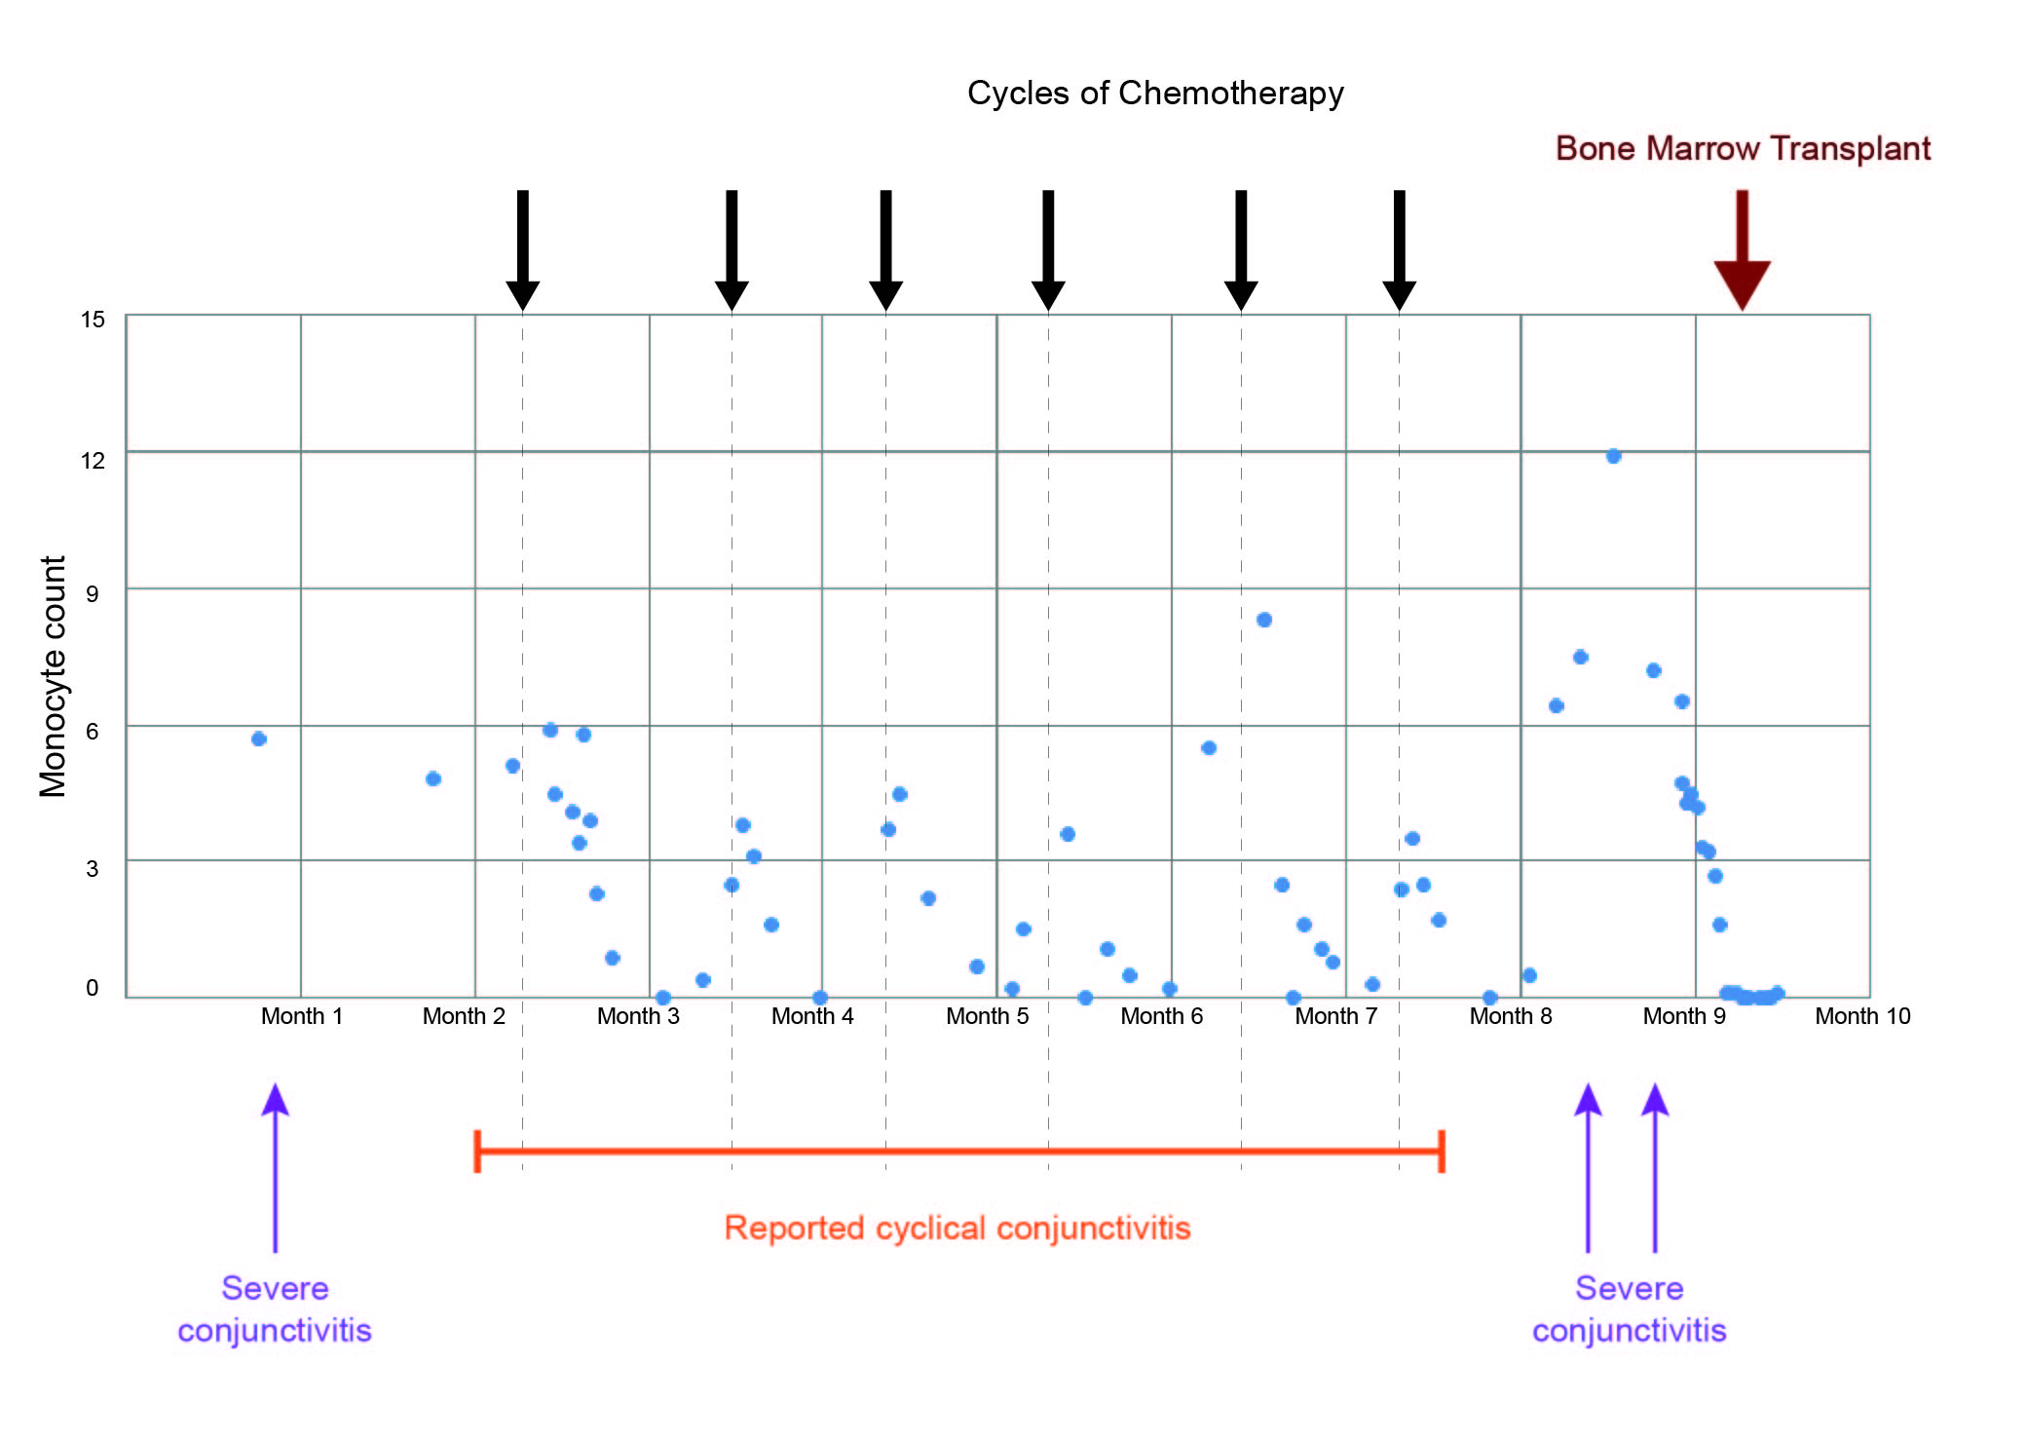
Figure 1 shows the monocyte count plotted against the date. The cycles of chemotheraphy have been marked onto the graph. It can be seen clearly how the monocyte level increases and is reduced by the cycles of chemotherapy. After the final cycle of chemotherapy, the monocyte count continues to increase exponentially which was in keeping with the patient’s severe symptoms. Following HSCT, the monocyte count returns to normal levels and the patient’s disease went into remission.

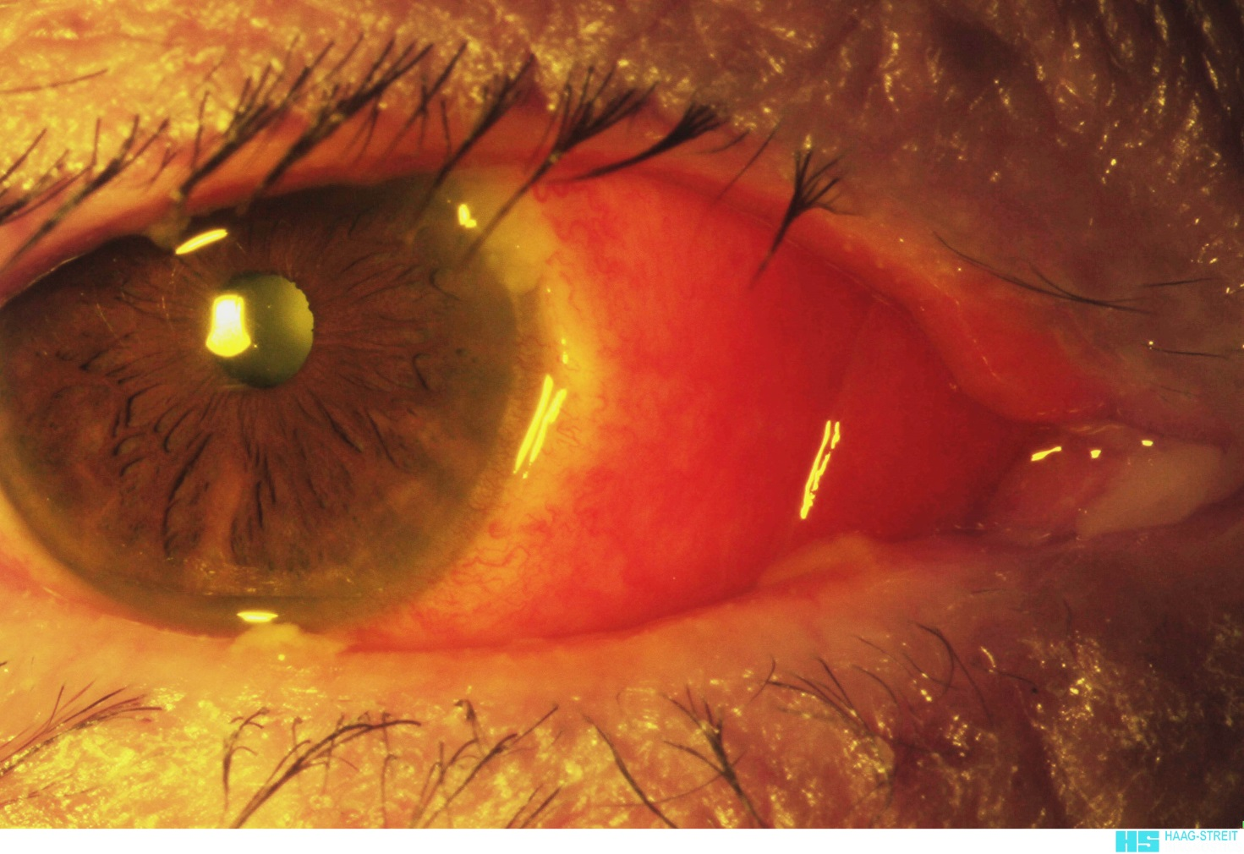
(a)

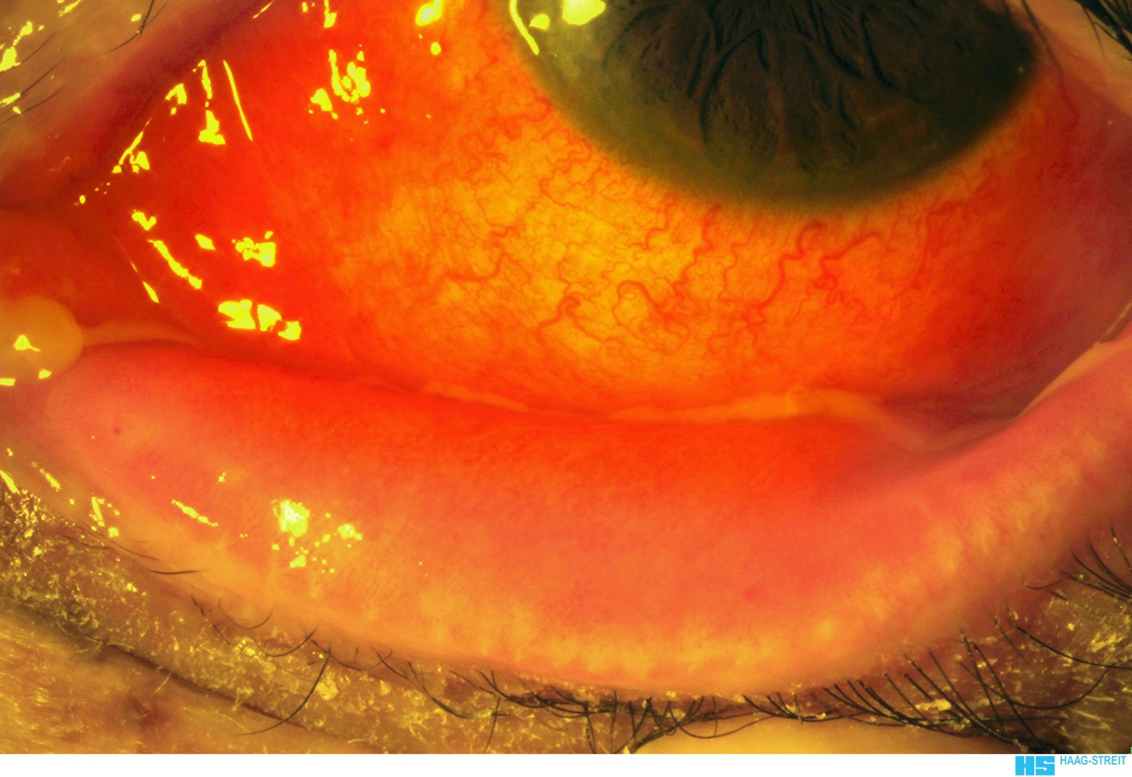
(b)
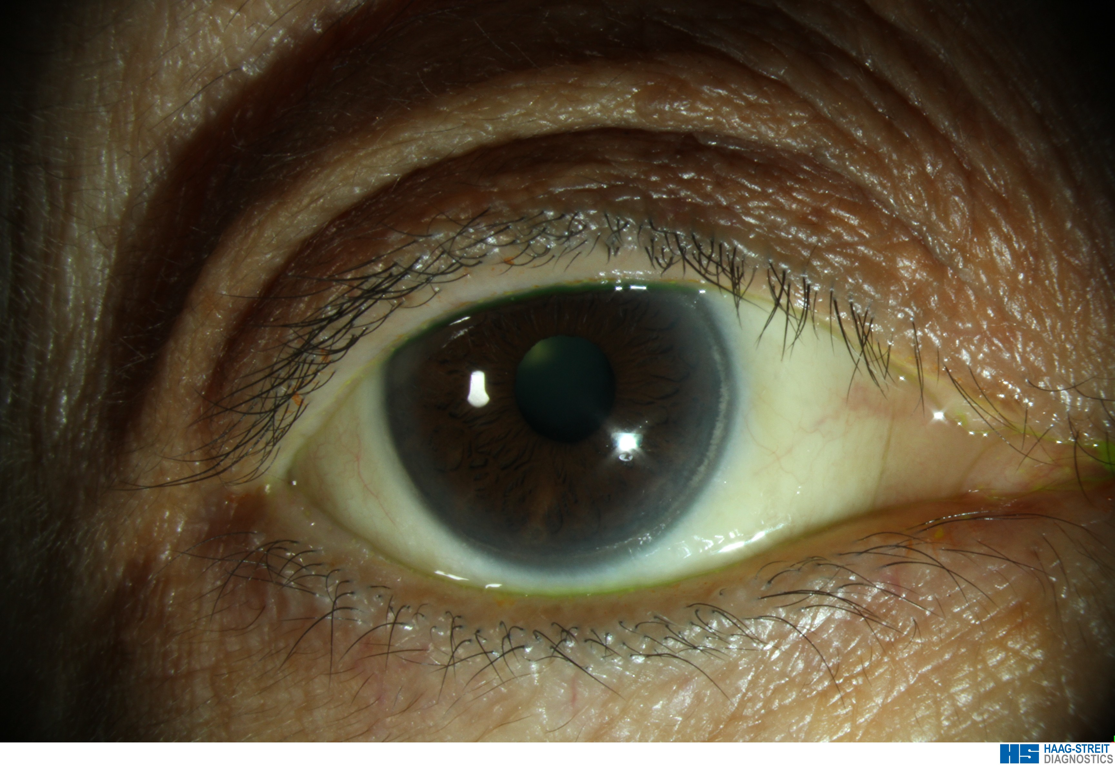
(c)

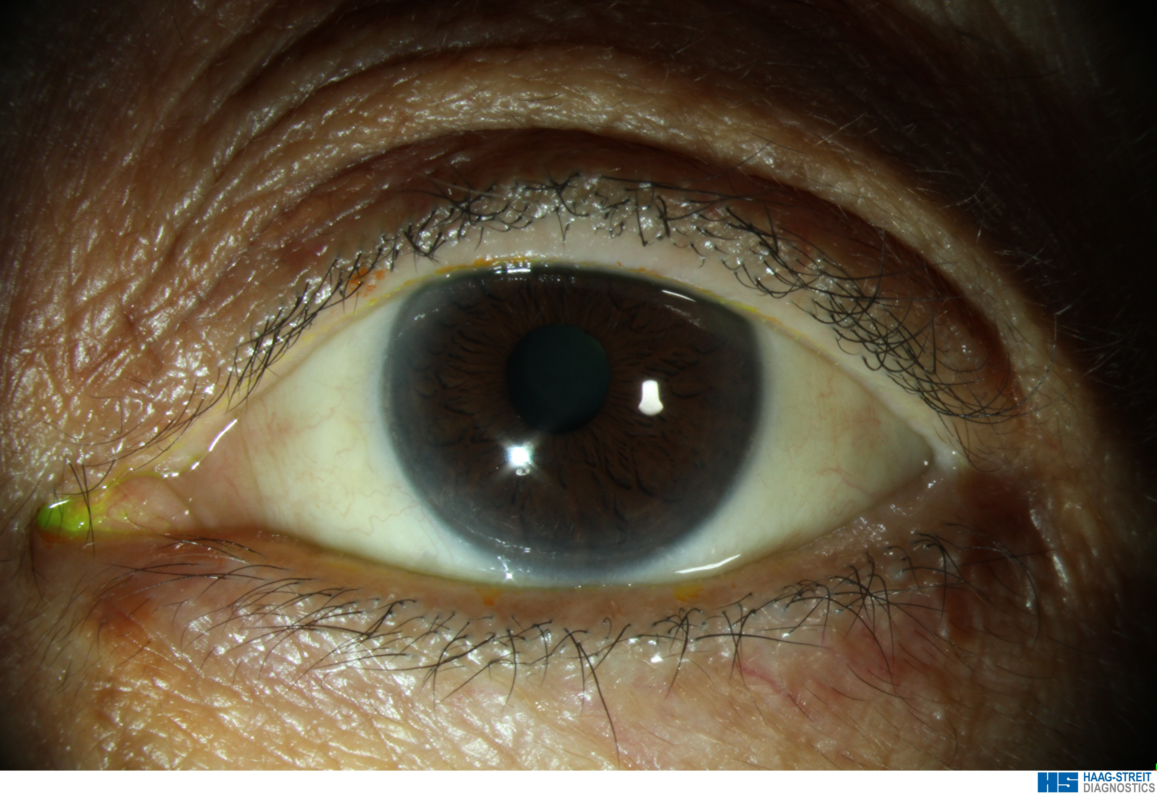
(d)

Figure 2

Photographs (a) and (b) show the right and left eye respectively whilst the patient has an elevated monocyte count before HSCT and is using hourly dexamethasone 0.1% preservative free drops. Marked conjunctival injection and oedema can be seen. Photographs (c) and (d) show the right and left eyes three months following HSCT and whilst the patient is not using any topical treatment. A reduction in conjunctival hyperaema and oedema can be observed.

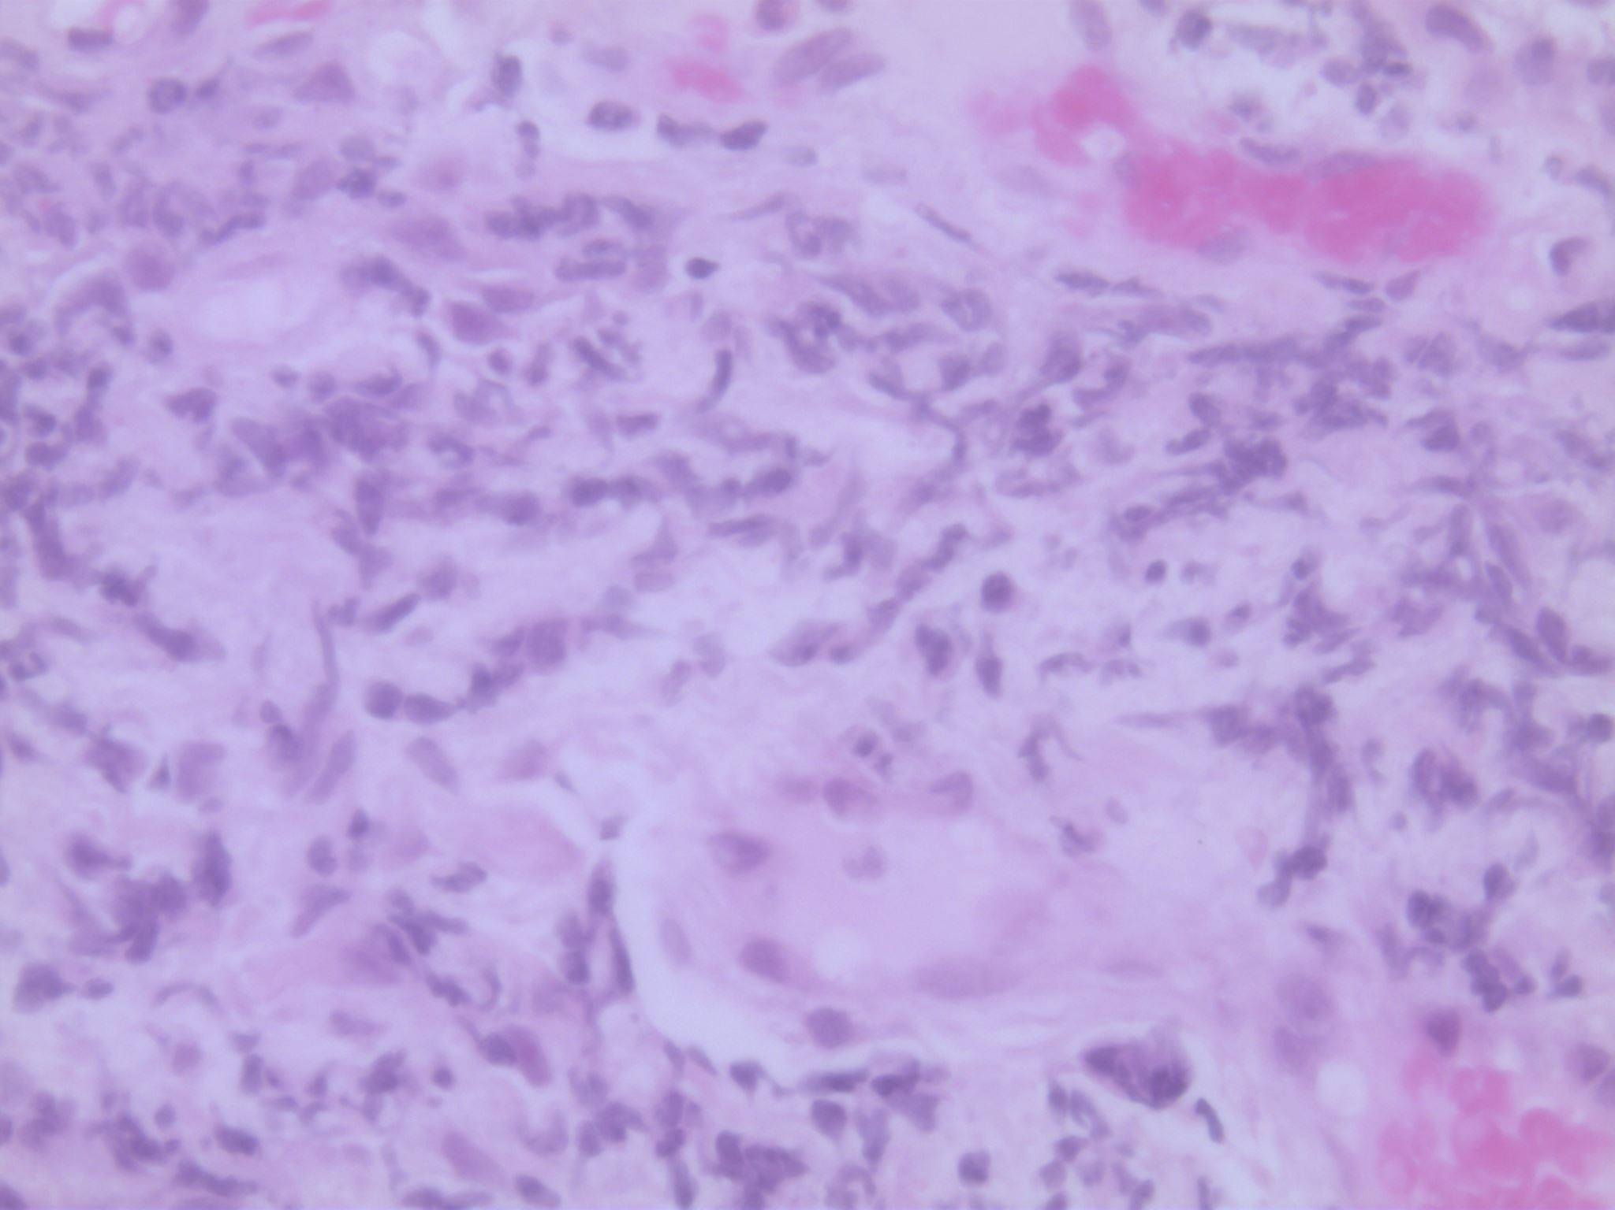
(a)

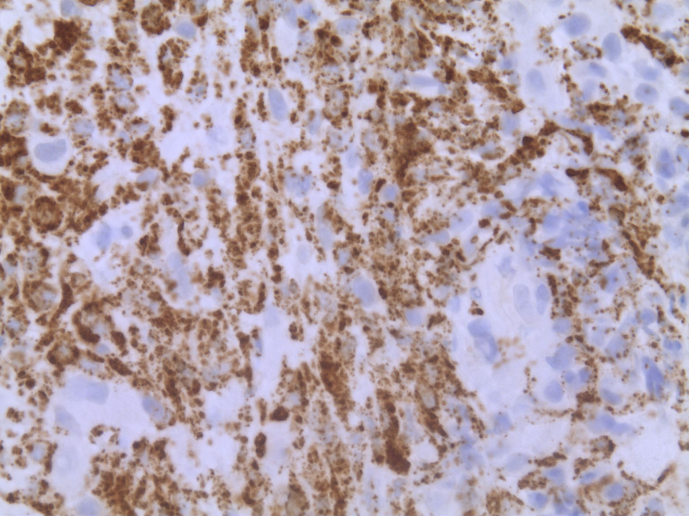
(b)
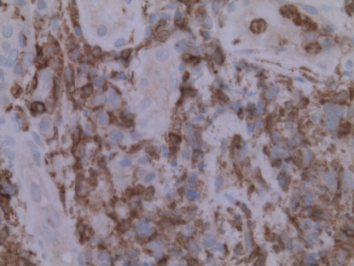
(c)

Figure 3

Haematoxylin and eosin staining (a) of a section of conjunctiva (60x) revealed dense inflammatory cell infiltration. Immunohistochemistry showed extensive staining for the macrophage marker CD68 (b). Immunohistochemistry staining with the marker CD14 (c) revealed a large population of these inflammatory cells to be monocytes.

DISCUSSION

Leukaemia may affect any tissue of the eye by direct invasion or secondary involvement. The posterior segment is more commonly affected with findings of increased retinal dilatation and tortuosity, haemorrhages, roth spots and leukaemic infiltrates. (3) In a retrospective study, Kezula et al, reported that 19 of 41 patients with myelodysplastic syndromes developed ocular complications including corneal ulcer, iridocyclitis, vitreous haemorrhage, retinal haemorrhage, cotton wool spots and optic neuritis. (4) Conjunctival involvement is rare but occurs most often in patients with lymphocytic leukaemias (5). Cases of chemosis, conjunctivitis, conjunctival mass and corkscrew vessels have been reported. (3)

In our case, the patient presented with conjunctivitis and was very symptomatic and resistant to treatment with topical steroids. Cycles of chemotherapy alleviated her symptoms and following a curative HSCT, her symptoms completely resolved. The conjunctivitis settled completely following HSCT. This is presumably due to normalization of the monocyte population and also to the immunomodulatory effect of HSCT. A biopsy was performed to examine for direct invasion of the conjunctiva but multidisciplinary review of immunohistochemistry by haematology and pathology concluded that this represented chronic inflammatory infiltrate. Secondary involvement with metastases was considered as ocular and leptomeningeal metastases can occur in leukaemias and lymphomas. (6) It was also important to consider Sweet’s syndrome which is characterised by fever, erythematous skin lesions and neutrophilic leucocytosis. (3)

Anterior uveitis and hypopyon have been described as a presenting feature of chronic myeloid leukaema. (7) Bypareddy et al describe two cases of anterior chamber hypopyon which were subsequently diagnosed as chronic myeloid leukaemia. Both cases resolved with induction of chemotherapy (8)

Patients with chronic conjunctivitis should be investigated to rule out masquerade syndromes. Referral to haemato-oncologist for further investigation and initiation of therapy may have potentially lifesaving implications.

REFERENCES

- Patnaik MM, Parikh SA, Hanson CA, Tefferi A. Chronic myelomonocytic leukaemia: a concise clinical and pathophysiological review. Br J Haematol. 2014;165:273-86
- Kipfer B, Daikeler T, Kuchen S, Hallal M, Andina N, Allam R et al. Increased Cardiovascular Comorbidities in Patients with Myelodysplastic Syndromes and Chronic Myelomonocytic Leukaemia Presenting with Systemic Inflammatory and Autoimmune Manifestations. Seminars in Hematology (2018), doi: 10.1053/j.seminhematol.2018.05.002
- Sharma T, Grewal J, Gupta S, et al. Ophthalmic manifestations of acute leukaemias: the ophthalmologist’s role. Eye (Lond) 2004;18:663–72
- Kezuka T, Usui N, Suzuki E, Wakasugi K, Usui M. Ocular complications in myelodysplastic syndromes as preleukemic disorders. Jpn J Ophthalmol. 2005;49:377–383. doi: 10.1007/s10384-005-0228-6.
- Duke-Elder S. System of ophthalmology. Cornea and conjunctiva, Vol V111. CV Mosby: St Louis, 1965; 1190–1195. 7 Allen RA, Straatsma BR. Ocular involvement in leukaemia and allied disorders. Arch Ophthalmol 1961; 66: 490–508. 8 Swartz M, Jampol LM. Comma-shaped venular segments of conjunctiva in chronic granulocytic leukaemia. Can J Ophthalmol 1975; 10: 458–461.
- Decker EB, Burnstine RA. Leukemic relapse presenting as acute unilateral hypopyon in acute lymphocytic leukemia. Ann Ophthalmol. 1993;25:346–349.
- Sudharshan S, Kumari A, Biswas J. Bilateral hypopyon as the presenting feature of chronic myeloid leukaemia.
- Bypareddy R, Takkar B, Azad SV, Chawla R. Anterior chamber exudation in chronic myeloid leukaemia. BMJ Case Rep. 2016 Nov 28;2016. pii: bcr2016217173. doi: 10.1136/bcr-2016-217173.

