Title: A case report: Dry eye disease?

Introduction
Ocular surface disease or dry eye syndrome are autoimmune disorders of the ocular surface. A recent study in Australia reported that more than 50% of people over 50 years of age suffer from dry eye symptoms, while women are more frequent affected.¹ Typical symptoms are epiphora, blurry vision, burning, redness and foreign body sensation.² Meibomian gland dysfunction (MGD) is the most frequent reason for dry eye symptoms in adults causing chronic inflammation and hyperkeratinisation of the conjunctiva.³ Patients with mild symptoms are often diagnosed with dry eye disease and not followed up by ophthalmologists constantly, although eye involvement can be present in several systemic autoimmune disorders, particularly in Sjogren´s syndrome, rheumatoid arthritis, lupus erythematosus, lichen planus, pemphigus, bullous pemphigoid, rosacea.⁴⁻⁷

Case Presentation with Illustrations and Figures
Here we describe the clinical course of a female patient, who was 58 years old at initial visit at our clinic. She presented with tearing and burning in her left eye for several weeks. The subjective visual acuity was unchanged. No symptoms were reported in the right eye. There were no operations or any ocular diseases in the past medical history. The patient had no internal diseases and did not take any drugs in the last months. The initial best corrected visual acuity was 20/25 on the right and 20/32 on the left eye. Intraocular pressure was normal. In the right eye a slight dysfunction of meibomian glands was remarkable, while conjunctiva, cornea and intraocular structures were not conspicuous. In the left eye also a meibomian gland dysfunction (MGD) was reported. Furthermore, a cicatricial conjunctival irritation was noticed subtarsal temporal and the conjunctiva was hyperemic. The first suggested diagnosis was MGD and cyclosporin 0.1% eye drops were prescribed. As a conjunctival scar was remarkable a conjunctival specimen was taken to exclude a chlamydia trachomatis infection. In addition vitamine A serum level and rheumatic parameters (ANA, ANCA, rheuma factor, Anti-Jo-1, Anti-Scl-70, Anti-Sm, Anti-SS-A (Ro), Anti- SS-B (La), Anti-
U1-RNP) were analysed in serum for considering autoimmune disorders. All tests were negative and MGD remained as the primary diagnosis. As the patient observed an increased blurred vision after two weeks of application of the ciclosporin eye drops she stopped these and mostly used artificial tears. 2 months after initial presentation the patient reported an increased pain and redness of the left eye. Also itching occurred as an additional symptom. The visual acuity was reduced (20/50) on the left eye. Conjunctival hyperaemia was increased, the scarred retraction unchanged and an irregular corneal surface with keratitis superficialis punctata was noticed. The right eye was normal with no discomfort. Due to ongoing meibum stasis and inflammation, oral doxycyclin 40mg once a day was prescribed for 6 weeks. In addition lubricating gel and oxytetrazyclin eye ointment was ordered. After further 6 weeks the patient had a visual decline (20/200) on her left eye. Slit lamp examination revealed serious keratitis superficialis punctata and a beginning formation of a tarsal symblepharon. Regarding the worsening of the symptoms and the general skin condition of the patient we supposed that a possible diagnosis could be blepharoconjunctivitis associated with rosacea. Due to acute deterioration we recommended local steroids, artificial tears as well as cyclosporin A eye drops.
About 6 months after initial presentation a conjunctival metaplasia was remarkable in the left eye.
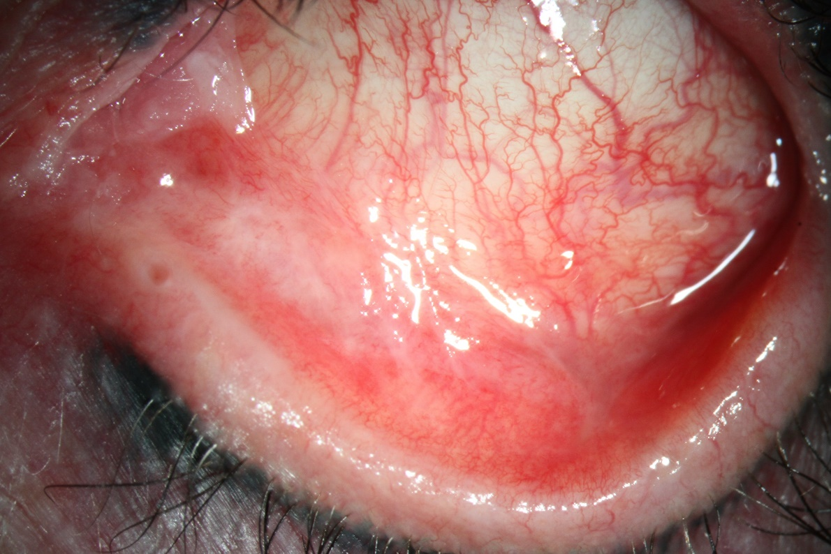
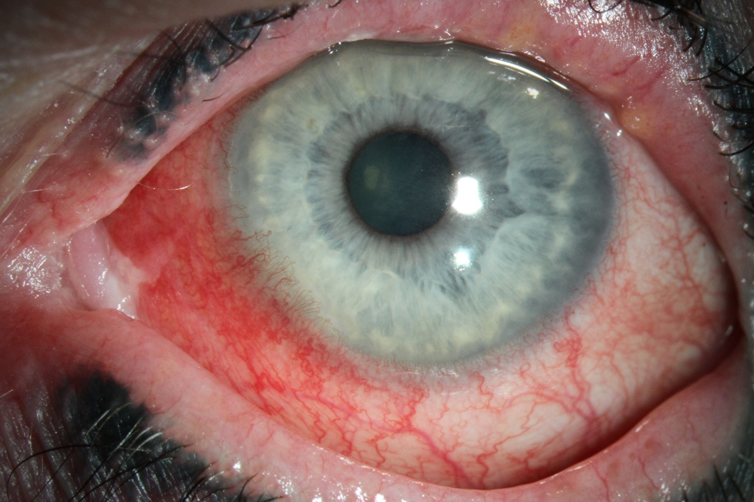

Figure 1. Clinical case presentation 6 months after initial visit. Progressive symblepharon formation, redness and conjunctival metaplasia in the left eye.

Due to this new finding a conjunctival biopsy was performed. The histological investigation revealed an acanthosis of conjunctival squamous epithelium and chronic inflammation with conjunctival scars. The pathological result explained no dysplasia or malignant signs. The oral therapy with doxycycline 100mg per os was continued for two more months. As a massive progression of symblepharon formation and beginning vasculatisation of the cornea was remarkable, a second conjunctival biopsy was performed with special remark on signs for ocular pemphigoid and lichen planus.
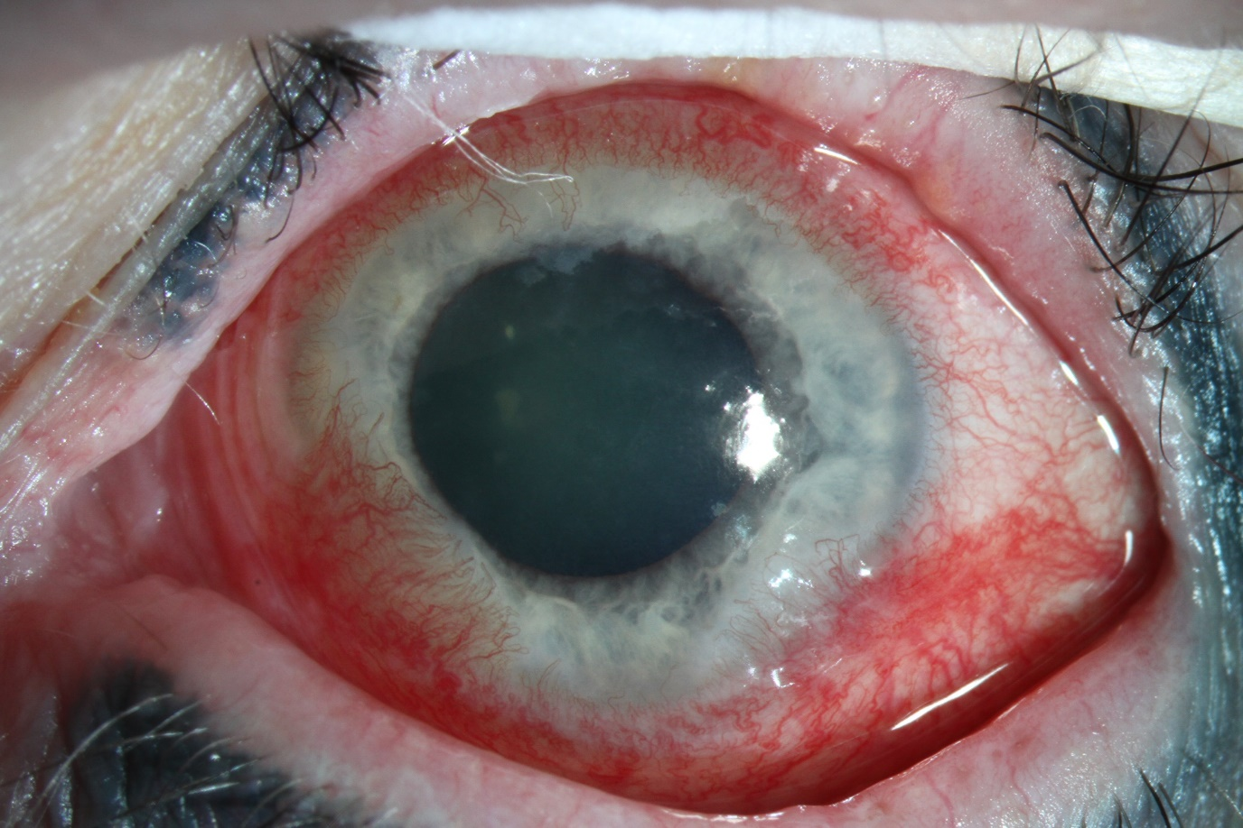
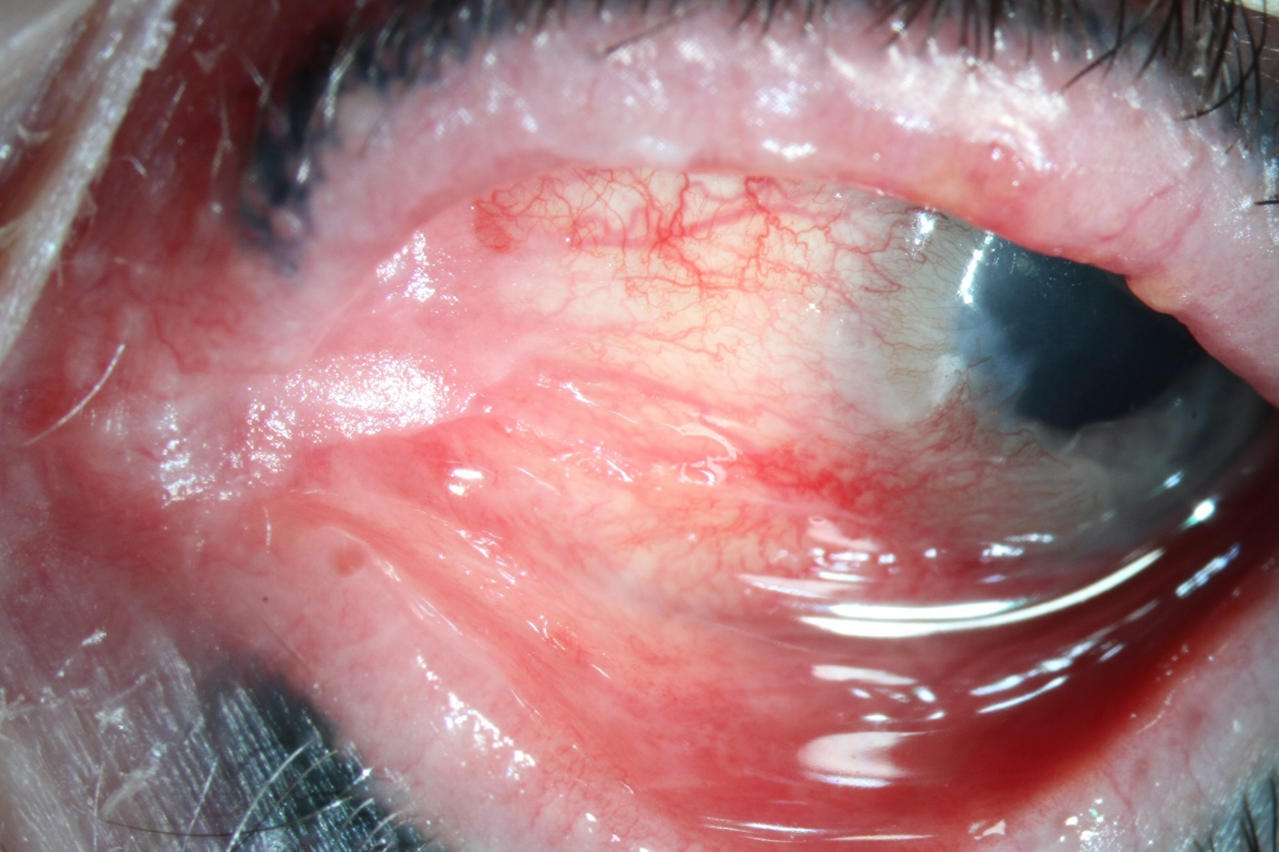

Figure 2: Massive deterioration at 8.5 months after initial presentation. Progressive symblepharon formation as well as corneal vascularisation in the left eye.

The histopathological result showed granular immunofluorescence of complement 3 (C3) at the basal membrane zone, what suggested lichen planus. Additional serum tests were performed with no detection of anti-basal antibodies. As an autoimmune disease was suspected, local immunosuppressive therapy (cyclosporin eye drops 1% and local corticosteroids) as well as systemic immune suppression (corticosteroids 1mg/kg body weight initial dose with slowly reduction, azathioprin 50mg) were administered. About 6 weeks of immunosuppressive therapy the patient showed a profound worsening of visual acuity (6/190), epiphora, pain and redness of the left eye. At the ophthalmological examination symblepharon formation was increased, scars and metaplastic conjunctival areas were not reduced. A progressive circular vascularization and subtotal corneal erosion were noticed. After a rapid progressive deterioration of corneal and conjunctival condition and a recently observed progressive strong swelling of the caruncula on immunosuppression over 2 months a third biopsy was performed.
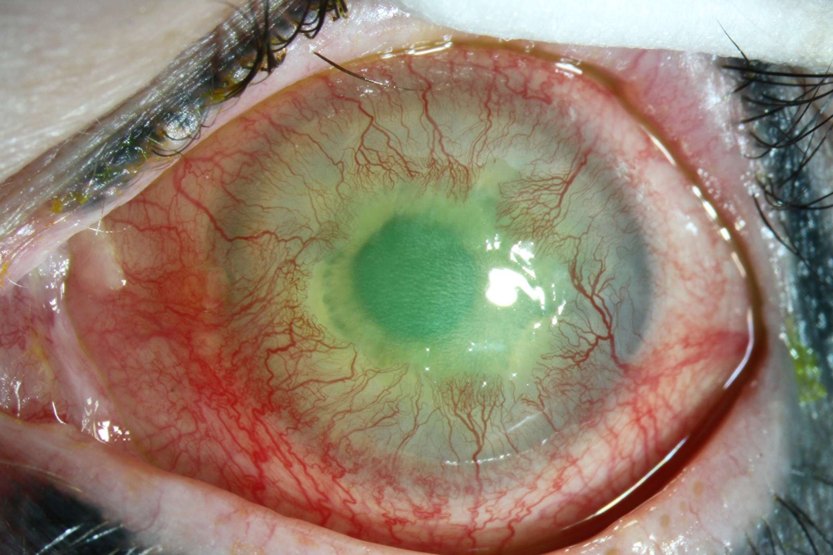
Figure 3: 2.5 months after local and systemic immunosuppressive therapy. Further deterioration of the conjunctival and corneal inflammation with massive vascularization and ongoing cicatricial conjunctivitis.

Within the operation a solid tumorous lesion was noticed next to the plica semilunaris. An encapsulated tumor, which expanded in the superior and inferior lacrimal canaliculus and posterior orbital region, was remarkable. The surgeon decided to excise a 10x10mm part of the lesion for histopathological analysis. A macroscopic full resection was not possible in primary surgery, due to the expanded manner of the lesion into the posterior orbit. The histopathological result was a high grade poorly differentiated neuroendocrine carcinoma of the left orbit (cN0 cM0). The systemic immunosuppressive therapy was stopped immediately. A cranial MRI investigation showed no signs of infiltration of the tumorous lesion in adjacent tissue or infiltration of the lamina papyracea. A local inflammatory reaction after excision of the tumor was conspicuous at the medial lid, conjunctiva and orbit. A full body F18-FDG-PET/CT showed also no signs of local enrichement of the radiopharmacon. Low enrichement was associated with the previous surgical excision. A conspicuous focus was visible in the right os ileum. Experts of different clinical departments (ophthalmology, oral and maxillofacial surgery, pathology, oncology, radiotherapy) discussed the case in a specialized tumor board. The common decision recommended a radical resection of the tumor and surrounding tissue. An orbital exenteration with following adjuvant radiochemotherapy was recommended as the prognosis of intraorbital poorly differentiated neuroendocrine cancer is poor.⁸ Also a biopsy of the focus in the os ileum was discussed. The patient refused this extensive surgery and decided to receive only radiotherapy and chemotherapy after a detailed consultation about the reduced prognosis was held with her. Currently radiotherapy (cyberknife; 6 cycles with 6 gray) is ongoing and a chemotherapy is planned to start (4-6 cycles of 3 weeks therapy with carboplatin and etoposid). The conspicuous focus in the os ilium should be reassessed after passed chemotherapy.
A trophic corneal ulcer appeared under radiotherapy which is under treatment with serum eye drops, local antibiotics (ofloxacin) and preservative-free artificial tears. The corneal integrity is stable at the moment while the visual acuity unfortunately decreased (hand movement).

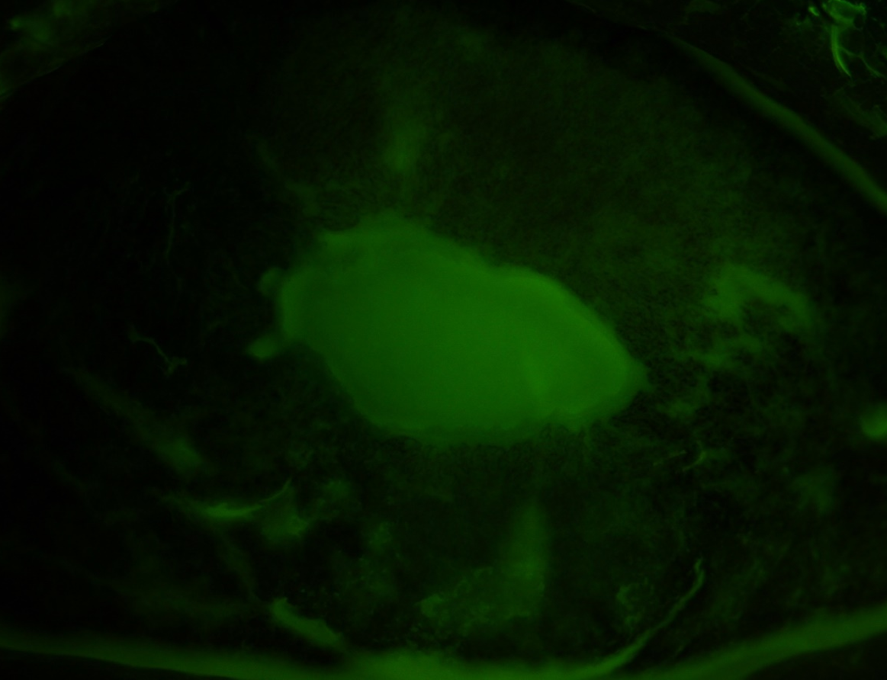
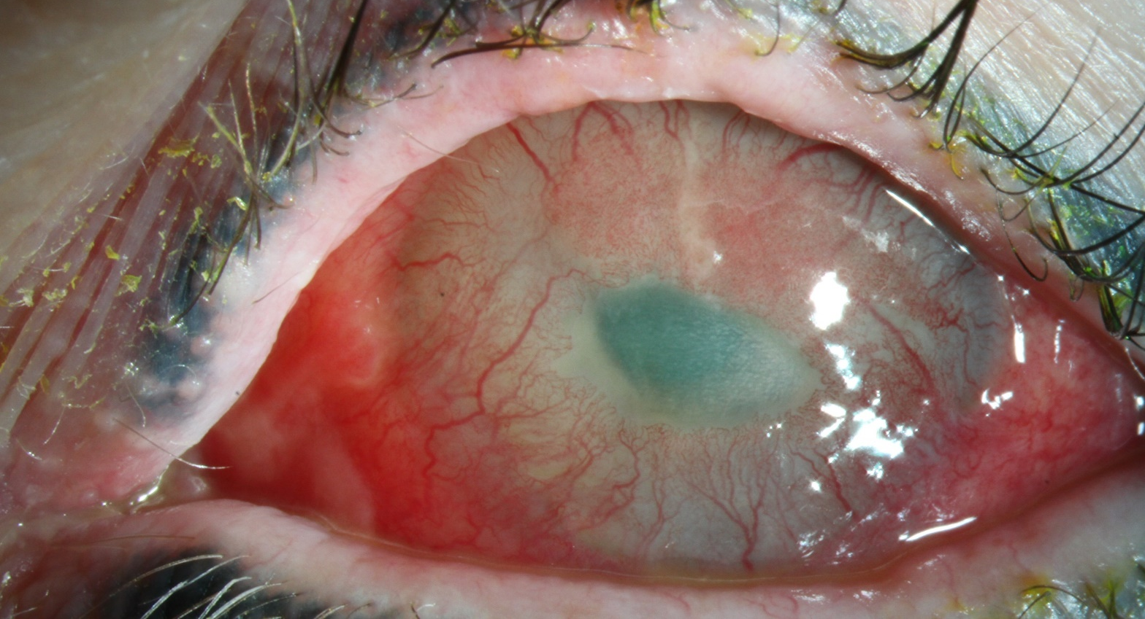

Figure 4: Trophical corneal ulcer with progressing vascularisation right after radiotherapy. Intense local therapy is necessary.

Discussion

The previous report describes a case with challenging diagnose finding. As the patient reported mild symptoms at good visual acuity at the initial visits meibomian gland dysfunction was supposed to be the diagnosis. While the presented symptoms were getting worse further investigations as conjunctival biopsy were performed for diagnose finding and a therapy was assimilated. Dermatological diseases as rosacea, acne vulgaris or atopic dermatitis can be associated with ocular surface diseases. Rosacea is a chronic skin disease commonly affecting sebaceous glands in patients between 50 and 60 years of age. Typical ocular manifestations are chronic inflammation of eye lids and conjunctiva.⁹ However also the formation of pyogenic granuloma, symblepharon and conjunctival adhesions as well as reduction of visual acuity were described in patients suffering from rosacea. ^{5, 10} Due to clinical observations and histopathological results of the conjunctival biopsy a blepharoconjunctivitis associated with rosacea was assumed. As a therapeutic effect of systemic doxycycline was absent, a second biopsy with special investigations was performed to especially prove if there were evidence for ocular pemphigoid or lichen planus. These are very rare disorders, yet they initially present with similar symptoms.^{6, 11} Progressive conjunctivitis, keratinization of conjunctiva and eye lids as well as symblepharon formation and keratopathy are well known findings in ocular pemphigoid. ^{12, 13} Ocular pemphigoid is a rare systemic chronic autoimmune disease which affects more women than men. In several cases diverse mucous tissues, e.g. oral, gastrointestinal or urogenital mucosa, are affected in addition to the conjunctiva. ^{12, 13} However, unilateral involvement of the eye may also occur at initial presentation.¹² Todays diagnostic standard is immunhistopathology examination using the immunofluorescent or immunoperoxidase technique of conjunctival biopsy as we performed in the presented case.¹⁴ Long term remission may be achieved by immunomodulatory therapy with corticosteroids, dapsone, methotrexate, azathioprine, mycophenolate mofetil, cyclophosphamide, rituximab or immunoglobuline in this disease.¹⁴⁻¹⁶ Furthermore, lichen planus, an inflammatory autoimmune disease, can present with uni- or bilateral ocular manifestation involving conjunctiva, cornea, and lacrimal drainage system. Typical findings are cicatricial conjunctivitis with subepithelial fibrosis, fornix shortening and symblepharon formation as described in the presented patient. ^{6, 17, 18} Also, systemic manifestation is possible with inflammatory affection of other mucosal tissue.^{19, 20} Dense linear and shaggy fibrinogen deposits and deposition of IgM and C3 along the basement membrane zone are typical for immunofluorescence in biopsy of the conjunctiva in lichen planus.²⁰ Topical therapy with corticosteroids and cyclosporine eye drops is recommended. In severe disease progression also a systemic immunosuppression should be administered. ⁶ Due to immunohistopathological analysis of the second biopsy the diagnosis lichen planus was considered in the present case and a topical and systemical immunomodulating therapy was applied as recommended.
As described before a massive deterioration was noticed after immunosuppressive therapy. Due to this observation a third biopsy was performed. During the operation a suspicious tumorous lesion was detected and partly removed for histopathological analysis. The histopathological result showed a neuroendocrine tumor. Single cases with paraneoplastic lichen planus associated with follicular, small-cleaved cell lymphoma and malignant thymoma were described previously.²¹ A paraneoplastic lichen planus is a very rare possible cause of cicatrizing conjunctivitis. To our knowledge an ocular paraneoplastic lichen planus without any other manifestations was not described yet. It remains unclear, whether the observed lichen planus is a secondary paraneoplastic finding caused by the neuroendocrine cancer or the primary disease. An exacerbation of the cancer manifestation under immunosuppressive therapy of the lichen planus should also been considered.
Neuroendocrine intraorbital tumors are very rare malignancies. In most cases they are metastases with primary tumors in other organs. Systemic symptoms can occur due to possible endocrine activity of the tumor. A wide spectrum of different cell types exists, while a poor differentiated high-grade neuroendocrine tumor is associated with a poor prognosis.

Conclusion

Diagnose finding in ocular surface disease is very challenging as different diseases can present initial similar symptoms. Dry eye symptoms are typical for several autoimmune diseases but can be also shown in context with infections, traumata or cancer.
In complex clinical cases with slowly progressive clinical manifestations, as presented here, months or even years can pass by until right diagnose making. A detailed photographical documentation can be very helpful in evaluation of slowly changing findings. Even though dry eyes are a widespread disease, dry eye symptoms should always be taken seriously and followed up by ophthalmologists. Frequent controls and intensive examinations with blood withdrawals for investigation of autoimmune markers and blood count, biopsy and also neuroimaging (craniofacial MRI) are important in complex cases with atypical symptoms and progressive courses as cicatrizing conjunctivitis and ocular surface disease may be associated with paraneoplastic disease and malignancy.

References

1. Chia EM, Mitchell P, Rochtchina E, Lee AJ, Maroun R, Wang JJ. Prevalence and associations of dry eye syndrome in an older population: the Blue Mountains Eye Study. Clin Exp Ophthalmol 2003;31:229-232.
2. Nebbioso M, Del Regno P, Gharbiya M, Sacchetti M, Plateroti R, Lambiase A. Analysis of the Pathogenic Factors and Management of Dry Eye in Ocular Surface Disorders. Int J Mol Sci 2017;18.
3. Knop E, Knop N, Millar T, Obata H, Sullivan DA. The international workshop on meibomian gland dysfunction: report of the subcommittee on anatomy, physiology, and pathophysiology of the meibomian gland. Invest Ophthalmol Vis Sci 2011;52:1938-1978.
4. Generali E, Cantarini L, Selmi C. Ocular Involvement in Systemic Autoimmune Diseases. Clin Rev Allergy Immunol 2015;49:263-270.
5. De Marchi SU, Cecchin E, De Marchi S. Ocular rosacea: an underdiagnosed cause of relapsing conjunctivitis-blepharitis in the elderly. BMJ Case Rep 2014;2014.
6. Mohebbi M, Mirghorbani M, Banafshe Afshan A, Towfighi M. Lichen Planus in Ocular Surface: Major Presentations and Treatments. Ocul Immunol Inflamm 2018;1-8.
7. Tan JC, Tat LT, Francis KB, Mendoza CG, Murrell DF, Coroneo MT. Prospective study of ocular manifestations of pemphigus and bullous pemphigoid identifies a high prevalence of dry eye syndrome. Cornea 2015;34:443-448.
8. Jorgensen M, Heegaard S. A review of nasal, paranasal, and skull base tumors invading the orbit. Surv Ophthalmol 2018;63:389-405.
9. Steinhoff M, Schauber J, Leyden JJ. New insights into rosacea pathophysiology: a review of recent findings. J Am Acad Dermatol 2013;69:S15-26.
10. Rahman MQ, Lim Y, Roberts F, Ramaesh K. Fibrosing blepharo-conjunctivitis following pyogenic granuloma in ocular acne rosacea. Ocul Immunol Inflamm 2010;18:346-348.
11. Williams GP, Nightingale P, Southworth S, et al. Conjunctival Neutrophils Predict Progressive Scarring in Ocular Mucous Membrane Pemphigoid. Invest Ophthalmol Vis Sci 2016;57:5457-5469.
12. Ahmed M, Zein G, Khawaja F, Foster CS. Ocular cicatricial pemphigoid: pathogenesis, diagnosis and treatment. Prog Retin Eye Res 2004;23:579-592.
13. Foster CS, Sainz De La Maza M. Ocular cicatricial pemphigoid review. Curr Opin Allergy Clin Immunol 2004;4:435-439.
14. Kirzhner M, Jakobiec FA. Ocular cicatricial pemphigoid: a review of clinical features, immunopathology, differential diagnosis, and current management. Semin Ophthalmol 2011;26:270-277.
15. Hingorani M, Lightman S. Ocular cicatricial pemphigoid. Curr Opin Allergy Clin Immunol 2006;6:373-378.
16. You C, Ma L, Anesi SD, Stephen Foster C. Long-term remission of ocular cicatricial pemphigoid off immunomodulatory therapy. Eur J Ophthalmol 2018;28:157-162.
17. Huang S, Channa P. Cicatricial keratoconjunctivitis associated with lichen planus. GMS Ophthalmol Cases 2015;5:Doc08.
18. Huerva V. Lichen planus on the ocular surface. Cutan Ocul Toxicol 2015;34:232-233.
19. Brewer JD, Ekdawi NS, Torgerson RR, et al. Lichen planus and cicatricial conjunctivitis: disease course and response to therapy of 11 patients. J Eur Acad Dermatol Venereol 2011;25:100-104.
20. Thorne JE, Jabs DA, Nikolskaia OV, Mimouni D, Anhalt GJ, Nousari HC. Lichen planus and cicatrizing conjunctivitis: characterization of five cases. Am J Ophthalmol 2003;136:239-243.
21. Hahn JM, Meisler DM, Lowder CY, Tung RC, Camisa C. Cicatrizing conjunctivitis associated with paraneoplastic lichen planus. Am J Ophthalmol 2000;129:98-99.

