Title: a case report: Atypical dry eye disease management: when eyes save life.
Dry eye syndrome is very common conditions that accrue mostly in elderly, leading to a poor life quality, signs and symptoms related to this condition are various, most Often, patients present with mild symptoms and which the ophthalmologists do not consistently monitor, although ocular involvement may be present in several cases of systemic autoimmune diseases.
Several pathologies can be at the origin of a dry syndrome, among them, primary or secondary Sjögren's syndrome, however, the clinician must know how to rule out differential diagnoses to allow quick initiation of treatment and minimize systemic complications.

Case Presentation with Illustrations and Figures:
A 55 years woman presented to our clinic for the first time with non-painful red eyes every morning while doing her morning routine the eye examination found phlyctenularblepharo conjunctivitis. Her visual acuity was unchanged. There was no surgery or eye disease in the medical history. However; the patient previously complained of xerostomia, asthenia and arthralgia; no medication was introduced in recent months apart from an occasional antidepressant drugs (amitriptyline) to relieve her anxiety (single patient).

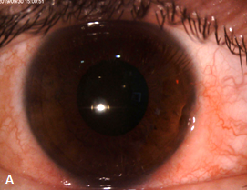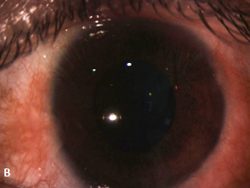
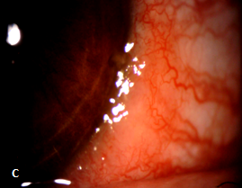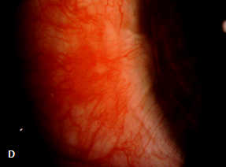
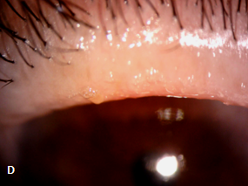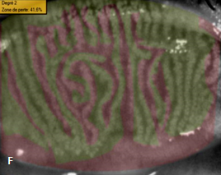
Figure1 : bilateral blepharoconjunctivitis OD (A,C,E). OS (B,D,F).
A nonsteroidal anti-inflammatory drug (NSAID) conservator free, 03 drops daily for a week was enough to bring a significant improvement in the anatomical aspect, a combined treatment with, Intense Pulsed Light therapy (IPL) and heated eye massager improved the Meibomian gland dysfunction.
03 months later, the patient complained of aching sensation. The fluorescein test and the non-invasive break-up time were in favor of a mixed dry eye, an immunological tests, a biopsy of the salivary glands came back negative(ANA, ANCA, rheuma factor, Anti-Jo-1, Anti-Scl-70, Anti-Sm, Anti-SS-A (Ro), Anti- SS-B (La), Anti-U1-RNP).

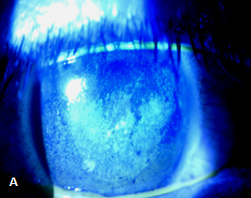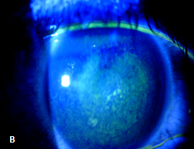
Figure2 : Superficial punctuate keratitis OD(A) OS(B).
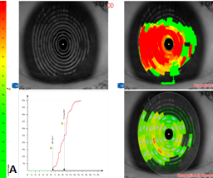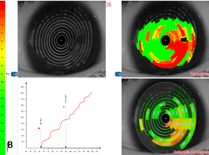
Figure3 :NIBUT :non invasive first break up time OD(A):6.4s/OS(B):3.3s
non invasive average break up time OD(A):9.3s /OS(B):8.9s
We instored cyclosporine 0.1% drops cure daily at night as well as omega 3 supplementation. The patient was lost to follow up ; she presented 6 months later with painful red right eye following accidental chemical exposure with cosmetic product (the patient is a hair professional ).The slit lamp examination found a deep corneal ulcer occupying 2/3 of the cornea with a nasal corneal neovascularization in addition of a pre perforatif corneal thinning the patient deliberately auto medicated using diclofenac sodium drops to relieve redness and itchiness.

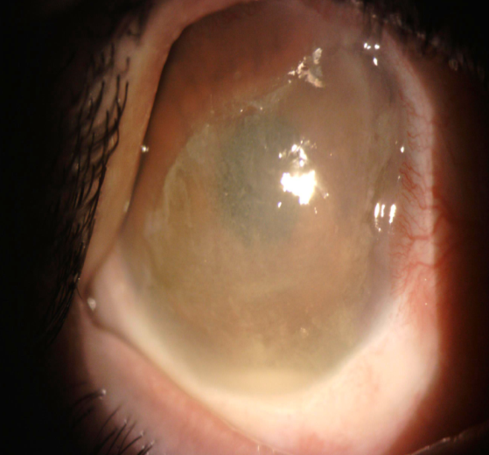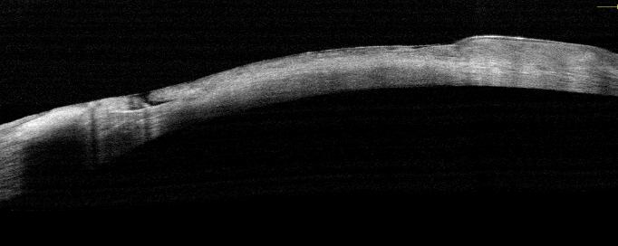
Figure4 : pre perforative ulcerative keratitis OD.
After hospitalization; a corneal and conjunctival samples were taken, a double topical antibiotic (ciprofloxacin, rifamycin) was instored.
our therapeutic strategy associated : An amniotic membrane graft that was placed in the bottom of the ulcer (inlay) in order to seal the pre perforative site (Figure 5) Topical bio-protectants (trehalose combined with hyaluronic acid) 6 drops daily , vitamin A-based ointment; 2 applications per day and a matrix therapy (polycarboxymethylglucose sulfate) one application twice a week.

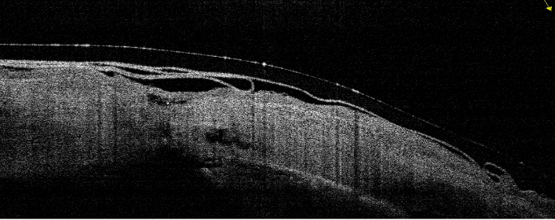
Figure5 : amniotic membrane lyophilized.

The patient evolved favorably with progression of corneal healing and epithelialization in the first week of her hospitalization. However, the biological assessments had found an unexplained chronic hyperglycemia and needed to be transferred to the endocrinology department, so we proceeded with placement of lacrimal plugs in order to avoid repeated instillation of the eye drops (Figure 6).

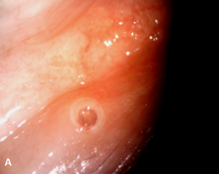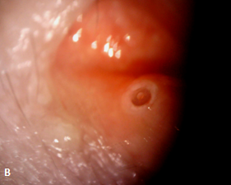
Figure6 :lacrimal plug OD(A) OS(B).
Inaugural diabetes was diagnosed, the immunological assessment, viral serology were negative as well as the salivary gland biopsy. However Lipasemia values were slightly increased to 60 u / L. Thoraco-abdominopelvic tomography found at the pancreas tail a 12 mm nodule with a well-defined partial necrotic center and a vascularized wall, the MRI confirmed it. There was no lymphadenopathy, nor infiltration of fat. Gastrin dosage is 885ng / L (normal value [VN] 15-110).
Distal pancreatectomy with lymph node dissection was performed. Histology and immunostaining confirms the diagnosis of gastrinoma (pT1N0).
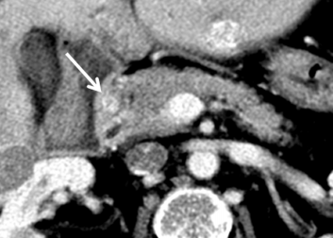
Figure7: CT scan transverse plan: small hypervascularized tumor in the pancreas tail (arrow).
After 3 months, the clinical status of the patient was re-evaluated weekly; the cornea has completely healed a part the thinning.
The patient reports a marked improvement in her life quality after being adapted with a scleral lens(20/80).
Figure :overview of the evolution of the keratoconjunctivitis sicca.
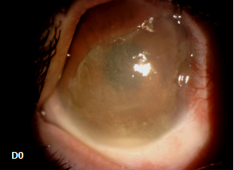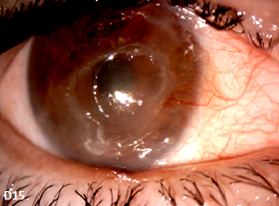
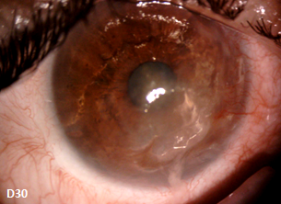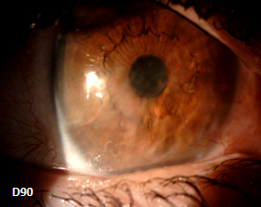
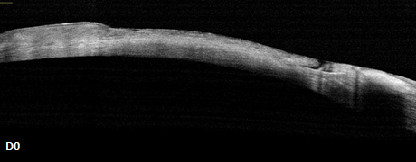

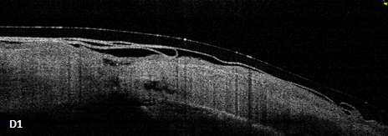

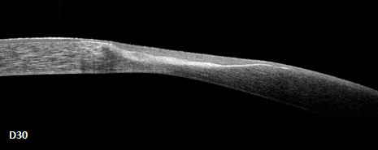
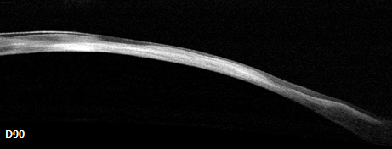

Discussion :

Dry eye is a new field of research and technical innovation. It’s important and unavoidable to know about its pathophysiology and therapeutic modalities. The life quality of patients with dry eye are numerous and diverse and depends of the level of dryness [1]. There may be classic symptoms such as discomfort to watch TV (reported by 71% of patients with dry eye),or makeup cessation (64%) but sometimes it may leads to depressions (2.5 times more frequent).it has been shown that dry eye was the cause of many sick-out of work [2] and could lead to stage 3 angina. It is therefore important to know how to detect the clinical and psychological repercussions. of those patients who suffer but whose clinical examination is sometimes poor as illustrated by the case of our patient.
New techniques and advancement strengthen the diagnosis and allows us to help our patients who suffer from this disabling and multifactorial pathology, whose treatment depends not only of a single treatment but on a combination of multiple treatments and techniques[3] The meibography is a non-contact infrared systems allow to obtain simply and quickly an overall imaging of the Meibomian glands[4], both at the upper and lower tarse .NIBUT automatically detects the rupture of the tear film, remains to specify its contribution in the etiological investigation, it gives more reliable values ​​than the conventional slit lamp BUT[5]. It locates and marks all the rupture zones on the Placido disks images and on the color-coded card according to the intensity of the breaks of the tear film, then establishes a curve graph of evolution of tear film breaks, The major interest is to have the tear film profile and rupture zones and not only the quantitative evaluation of the first rupture time and the mean time of all breaks [6]. Therapeutic strategies will therefore target different mechanisms through the combination of different therapies [7]. Recently, new therapies have been added to expand the pharmacy of the ocular surface.
The therapeutic effects of IPL, which remodel conjunctival tissue disorganized by blepharitis, coupled with the thermal effect of heated massage glasses that are beneficial for Meibomian secretions have changed the outcome of the MGD management [8]. Bioprotection achieved with the combination of trehalose and hyaluronic acid allows better protection of the suffering cells and contributes to the integrity of the tear film homeostasis confirmed by randomized studies [9].about corneal scarring, the new matrix therapy Poly (carboxymethylglucose sulfate) can be used in corneal healing problems, particularly in ulcers following severe drought, with good results in adults as well as in children [10]. This proved effective in this case. An amniotic membrane graft is indicated for ulcer thinning and corneal perforation; due to growth factors as well as protease inhibitors, it provides an extracellular matrix that helps the migration of peripheral ulcer cells towards the center [11]. It is used as a biological patch sutured to the conjunctiva (overlay) or in the bottom of the corneal ulcer (inlay) in one or more layers [12].The nonsteroidal anti-inflammatory drugs (NSAIDs) that were used voluntarily by the patient have a very interesting analgesic action but have high risk of keratolysis, that must be avoided in case of corneal epithelial thinning [13]. The lacrimal plugs whose effectiveness on the signs and symptoms of dry eye has been quickly and recently proved [14] . Moderate to severe dry eye secondary to an aqueous deficient type is the main indication for lacrimal plugs. They improve the clinical symptoms and the state of the ocular surface while decreasing the use of tear substitutes, which they complement the action, in patients with lake of control (the case of our patient who had to be operated urgently for her pancreatic gastrinoma) They can also be associated with other topical ocular surface treatments.such as autologous serum [15]. Several systemic and autoimmune diseases may have as a starting point a dry eye, the symptomatoms as it illustrated in the previous case. The symptoms are often mild and not specific but their persistence , aggravations and recurrence requires an etiological investigation[16]. Recent diabetes and pseudo-Sjögren should seek a neoplasic cause.
The diagnosis of sporadic pancreatic gastrinoma(absence of duodenal ulcer or diarrhea) remains difficult[17]. In 60% of cases, the gastrinoma is malignant and sometimes metastatic. surgery is the choice treatment for gastrinoma.

Conclusion:
Although dry eye is a common disease, its symptoms must always be taken seriously and followed by ophthalmologists. With the help of new techniques that allow a better understanding of the pathophysiology of dry eye, and should be an integral part of our diagnostic and therapeutic strategies for atypical and progressive symptoms because an ocular surface disease can reveal a potentially life-threatening disease.
References
[1] Research in dry eye: report of the Research Subcommittee of the International Dry Eye WorkShop (2007). Ocul Surf, 2007;5: 179-193
[2] Baudouin C, Creuzot-Garcher C, Hoang-Xuan T et al. Creating a specific diagnostic and quality life questionnaire for patients with ocular surface disease. J Fr Ophtalmol, 2003;26:119-130.
[3] Jones L, Downie LE, Korb D et al. TFOS DEWS II Management and Therapy Report. Ocul Surf, 2017;15:575-628.
[4] Pult H, Riede-Pult BH, Nichols JJ. Relation between upper and lower lids’ meibomian gland morphology, tear film, and dry eye. Optom Vis Sci, 2012;89:310-315.
[5.6] Cho P, Douthwaite W. The relation between invasive and noninvasive tear break-up time. Optom Vis Sci, 1995;72:17-22.
[7] Wolffsohn JS, Arita R, Chalmers R et al. TFOS DEWS II Diagnostic Methodology report. Ocul Surf, 2017;15:539-574.
[8] Vora GK, Gupta PK. Intense pulsed light therapy for the treatment of evaporative dry eye disease. Current opinion in ophthalmology, 2015;26:314-318
[9] Chen W, Zhang X, Liu M et al. Trehalose protects against ocular surface disorders in experimental murine dry eye through suppression of apoptosis. Experimental eye research, 2009;89:311-318.
[10] Khammari-Chebbi CK, Kichenin K, Amar N et al. Pilot study of a new matrix therapy agent (RGTA OTR4120) in treatment-resistant corneal ulcers and corneal dystrophy. J Fr Ophtalmol, 2008;31:465
[11.12] Mohan S, Budhiraja I, Saxena A et al. Role of multilayered amniotic membrane transplantation for the treatment of resistant corneal ulcers in North India. Int Ophthalmol, 2014;34:485-491
[13] Bourcier T, Acosta MC, Borderie V et al. Decreased corneal sensitivity in patients with dry eye. Invest Ophthalmol Vis Sci, 2005;46:2341-2345.
[14.15] Tai MC Cosar CB Cohen EJ Rapuano CJ Laibson PR . The clinical efficacy of silicone punctal plug therapy. Cornea. 2002;21:135–139
[16] Sawicki MP, Howard TJ, Dalton M, et al. The dichotomous distribution of gastrinomas. Arch Surg 1990;125:1584–7.
[17] Lopez CL, Falconi M, Waldmann J, et al. Partial pancreaticoduodenectomy can provide cure for duodenal gastrinoma associated with multiple endocrine neoplasia type 1. Ann Surg 2013;257:308–14.

